School of Science and Technology
Student Name: Omoniyi Shammah
Student Id No:
Module number: ITX3999

I hereby confirm that the work presented here in this report and in all other associated material is wholly my own work. I confirm that the report has been submitted to TURNITIN and that the TURNITIN results are on CD attached to this report. I agree to assessment for plagiarism.

Signature: ………………….
Date: 7/13/2020

ACKNOWLEDGEMENT
I would like to thank my supervisors, Mr Judhi Prasetyo very much for their helpful feedback, advice and recommendations throughout the project. I would like to thank him very much. I would also like to thank Dr Fehmida Hussain for consistently inspiring me to work harder and for encouraging me to take academic learning sessions.
Table of Contents
ACKNOWLEDGEMENT 3
TABLE OF FIGURE 6
Abstract 7
1 Introduction 7
2 BACKGROUND/ LITERATURE REVIEW 7
2.1 BRIEF HISTORY OF BOOKING SYSTEM 8
2.2 COMPUTER-BASED INFORMATION SYSTEM 8
2.2.1 ADVANTAGES OF COMPUTER-BASED INFORMATION SYSTEM 8
2.3 TOOLS AND TECHNOLOGY 8
2.4 COMPARISON BETWEEN EXISTING SYSTEMS 9
2.4.1 Vetstoria 9
2.4.2 VetO 9
2.4.3 Similarities Between software 9
2.5 CHALLENGES OF EXISTING APPLICATION 9
3 REQUIREMENT SPECIFICATION 9
3.1.1 USERS 9
3.1.2 DEVELOPMENT 9
3.2 USER REQUIREMENT 10
3.2.1 SURVEY RESULT 10
4 REQUIREMENT ANALYSIS 11
4.1 FUNCTIONAL REQUIREMENTS 11
4.2 Non-Functional Requirements 11
5 System Analysis and Design Phase 12
5.1 USE CASE DIAGRAM 12
5.2 SYSTEM ARCHITECTURE 13
5.3 ENTITY RELATIONSHIP DIAGRAM 14
5.4 STORYBOARD 15
5.5 USER INTERFACE 16
6 SYSTEM IMPLEMENTATION AND DEVELOPMENT 18
6.1 FRAMEWORK - Agile Software Development (ASD) 18
6.1.1 When to Use Agile Model 18
6.1.2 Advantages of Agile Methodology 19
6.1.3 Disadvantages of Agile Methodology 20
6.2 IMPLEMENTING THE APPLICATION 20
6.2.1 Splash Screen 20
6.2.2 User Sign Up 21
6.2.3 User Sign In 22
6.2.4 User Book Appointment 23
6.2.5 Doctor Retrieving Tasks 24
6.2.6 Doctor Profile 25
6.2.7 User Profile 26
6.3 LIBRARIES USED FOR VET BOOK APP DEVELOPMENT 27
6.3.1 JUnit 4 Library 28
6.3.2 Recycler View Library 28
6.3.3 Card View Library 28
6.3.4 Circle View Library 28
6.3.5 Google Material Design 28
7 Testing and Evaluation 28
7.1 Functional Testing 28
7.2 Unit Testing 28
7.2.1 Testing 29
7.3 Performance Testing 30
8 Conclusion 30
8.1 Reflection 30
8.2 Future Work 31
8.3 Personal Development 31
9 Reference 31
10 Appendix 32
10.1 Appendix A 32
10.2 Appendix B 33
10.2.1 Consent form 33
10.2.2 Declarative form 33

TABLE OF FIGURE
Figure I: Use case Diagram. 12
Figure II: System Architecture 13
Figure III: ER Diagram Cardinality 13
Figure IV: ER Diagram. 14
Figure V: Storyboard: VET ONLINE BOOKING SYSTEM 14
Figure VI: First Page of The Application 15
Figure VII: Login Page of The Application 15
Figure VIII: Sign up Page of The Application. 16
Figure IX: Share Location 16
Figure X: The Home Page of the Application 17
Figure XI - Splash Screen source code 20
Figure XII - User Sign Up Source code 21
Figure XIII - User Sign In Source Code 22
Figure XIV - User Book Appointment Source code 23
Figure XV - Doctor Retrieving Tasks Source code 24
Figure XVI - Doctor Profile Source code 25
Figure XVII - User Profile Source code 26
Figure XVIII - The libraries used 26
Figure XIX - Schedule Sheet 28
Figure XX - Consent Form 28
Figure XXI - tester 1 result 29

REPORT STRUCTURE
This report is structured, as explained below:
- Abstract: This section describes the description of this project, the form of software, its purpose, its approach to the solution and the process used to create the project.
- Introduction: This segment provides a summary of the proposal, its purpose, goal, goal and nature of the project.
- Background and Literature Review: This segment outlines the project's history and timeline. It explains the structures that were in operation before my project and their significance.
- System Analysis and Design: this segment includes project management, data processing, data creation and other information system preparation that requires the task.
- Implementation: This segment describes the technologies used and what it feels like (user interface).
- Evaluation: demonstrates the evaluation carried out in the document and changes made.
- Future work and Discussion: a short description of jobs, drawbacks and potential plans.
- Re

Abstract
This project presents the theoretical framework of the veterinary online booking system, discusses the different scholars' perspective of the online booking system, this project aims to develop an online booking system for clients to make reservations at their convenient time because at present. The project discussed the tool and technology used in the development of the proposed project. Two online reservation systems were compared to identify their similarities and differences. Several development methodologies have been discussed and why one of the methods has been chosen for this project. Methods used to gather specification of requirements have been considered, which the researcher will use this as a guideline for the development of the proposed system. Unified Modelling Language Diagrams describing each system has been created. Demonstration of the different pages available on the application was discussed, and an evaluation was carried out to evaluate the application.

Introduction
Information systems are now part of an individual's daily activities. It has increased the efficiency and decreased the time for the process. With the help of an online booking system companies like veterinary clinic are now able to connect with both existing and prospective customers online. This is the fastest and efficient way to interact with customers compare to manual booking reservation. Most veterinary clinic in Nigeria currently uses a manual booking system to keep a record of customer's information, make a reservation and store these reservations in a manual file. A proposed solution will be introduced to implement where an online application reservation system will be developed and deployed to customers to make their reservation at a convenient time and place. The reservation will immediately be confirmed by the veterinary clinic application. The application will keep users informed about their bookings and the opening and closing of the veterinary clinic around them. Besides, by using the application, users can view the clinic ratings instead of going online to look for a trusted veterinary clinic.

BACKGROUND/ LITERATURE REVIEW
The internet is widely used by many organisations, institution, and even for personal use today, it had become a significant trend because of the way it provides free information exchange daily (Palmer, 1999). Over 400,000 networks in the world today are communicating with each other (Rivers & Judd, 2001). The internet is also used to gather information regarding a place such as a vet clinic and even make a reservation with that clinic online.
Online reservations are becoming a prevalent method for booking rooms in a hotel that operates online. This is the fastest way to contact and communicate with a hotel (James,2008). Ivanovo Mathew (2008) defined online booking "as a tool to store, publish and update the dynamic data availability and prices and additionally provide the users with a regular reservation process".
According to a study (Nurmela, Marja-Leena, 2016), it was recorded that 44% of pet owners in Finland (386 answers) want to book their visit through a veterinary online booking system primarily. Calls came as a second alternative to book their visit, with almost the same result 43.3%. Additionally, 27 % wanted to book their appointments with mobile applications (this is offered in Finland for Provet clients) or 9% with a chat application. Being that 27% of the user only wanted to book through the mobile application, there will be an implementation of an online view to the application to give the user the feel of using an online platform.
Recent days have seen a sharp increase in the need for an enhanced online veterinary booking system for users and veterinarians. In the case of each veterinarian, seeing there does not have time to manually enter and report the pet issue of the client, the vital period for veterinarians to administer all drugs, testing, and care for support staff.

Project Aim
To build a mobile application for users to book appointments with a veterinary clinic in their immediate vicinity.

PROJECT OBJECTIVE
- Carry out research on the existing booking application to investigate weakness and designs
- Conduct user requirement survey.
- Create system design.
- Design application prototype (wireframing).
- Implement all system and practical design to the actual software.
- Conduct application Evaluation

BRIEF HISTORY OF BOOKING SYSTEM
The experimental electromechanical reservator, the first automatic booking system, was developed at American Airlines in 1946. The Magnetron Reservisor quickly followed a new system with temporary storage based on a magnetic drum.
Trans-Canada Airlines (TCA) began investigating a computer-based remote terminal system in 1953, testing one design on the Manchester Mark 1 machine at the University of Toronto that summer.
In March 2007, as a result of the merger with Air France, KLM Royal Dutch Airlines switched to Amadeus through its reservation system (CORDA).
JetBlue migrated its reservation program to the SabreSonic User Sales and Supported network in February 2010.
Turkish Airways immigrated from Sabre to Hitit in September 2018

COMPUTER-BASED INFORMATION SYSTEM
The computer-based information system is an information system in which data is primarily obtained, preserved and interpreted in a digital environment through computerised processes. In the same way, knowledge is received in digital format by computerised mechanisms.

ADVANTAGES OF COMPUTER-BASED INFORMATION SYSTEM
- There is very little likelihood of error in computerised systems when processing details.
- The computerised program requires a tiny room to store information.
- Computerised program is a safe place to hold information.
- Computers can do any kind of research frequently without getting exhausted or bored.

TOOLS AND TECHNOLOGY
The various tools used in developing the system are Android Studio (the primary IDE for native Android app development which provides code editing, debugging, and tools testing), Gradle (Used to add external libraries), IntelliJ IDEA (a full suite of development tools).
C++: It is the simplistic base for most programming languages and possesses the power to create dynamic apps. It is a sister language, Objective-C and is used for app development in android systems.
Java: It is an object-oriented programming language, which is easy to handle, and many open-source libraries are made available for users to choose from.
HTML5: There is no better technology to use than HTML5 if your organisation is looking at developing web-frontend applications for mobile devices.

COMPARISON BETWEEN EXISTING SYSTEMS
A comparison of two similar systems that operate the same proposed system (Veterinary online reservation system) was made to identify the differences and similarities. The four systems chosen are Vetstoria, VetO, Aria, and VitusVet

Aria
Aria is an intelligent and versatile software to help veterinarians capture, view and report high-quality images (Veterinary Software, 2020)
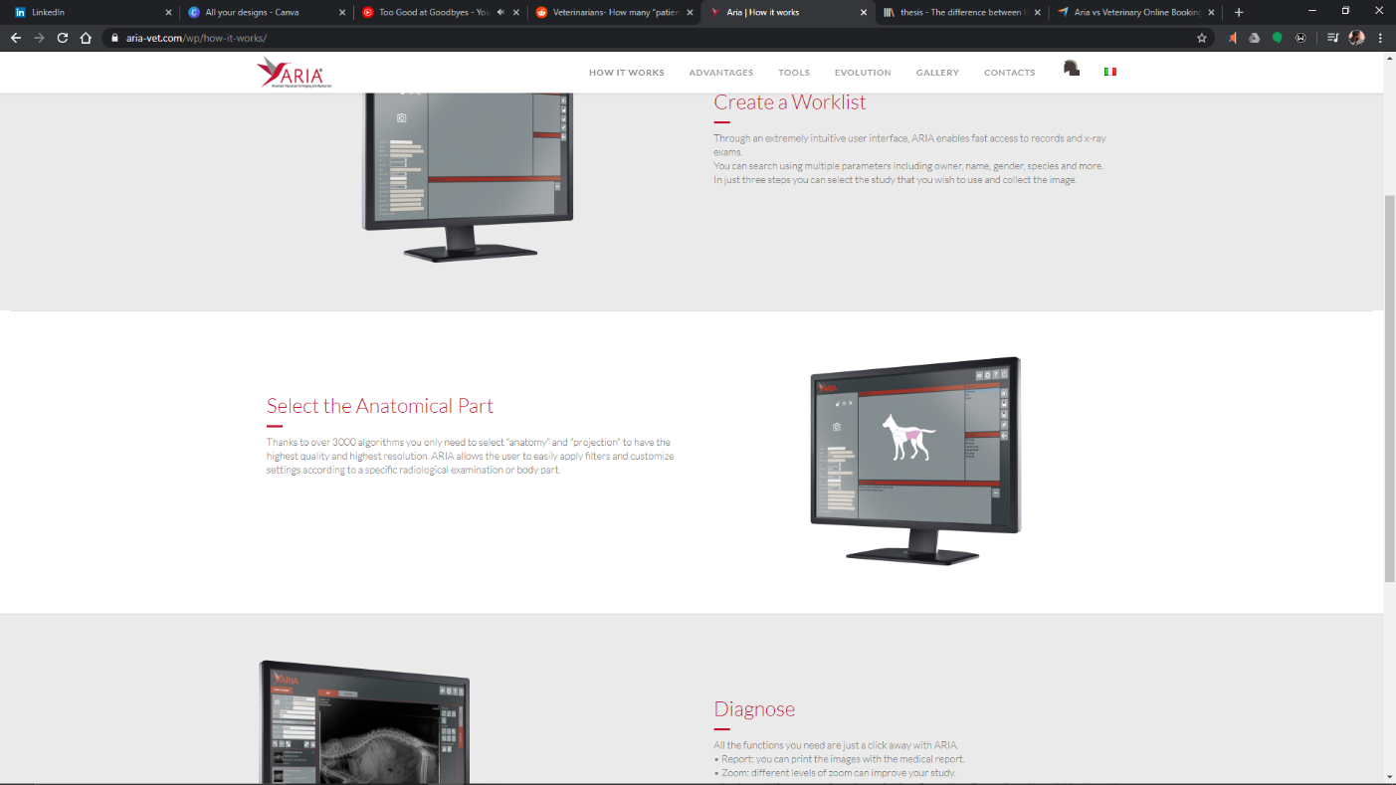
Figure I: Aria 1.
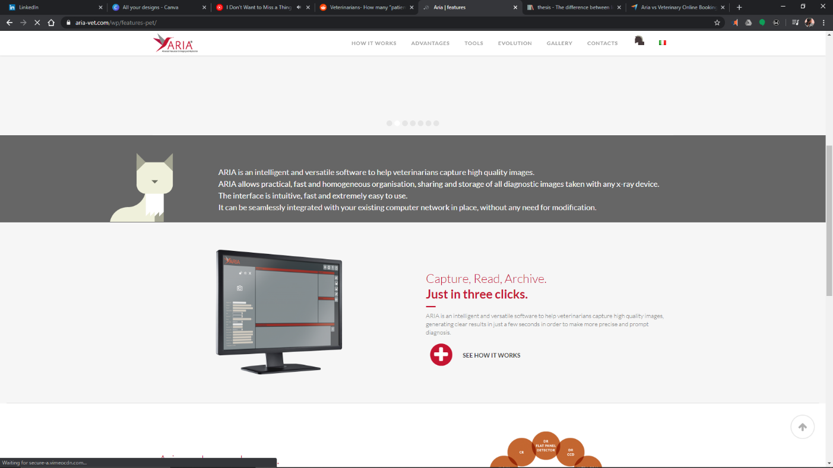
Figure II: Aria 2.

Vetstoria
Vetstoria provides online appointment scheduling for vets, which simplify the client scheduling process by seamlessly integrating with the practice management software of veterinary practices. (Veterinary Software, 2020)

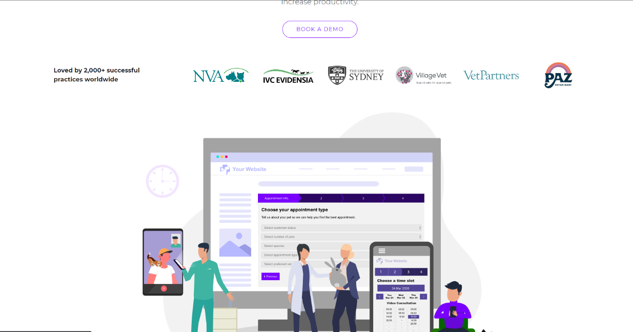
Figure III: Vetstoria 1.
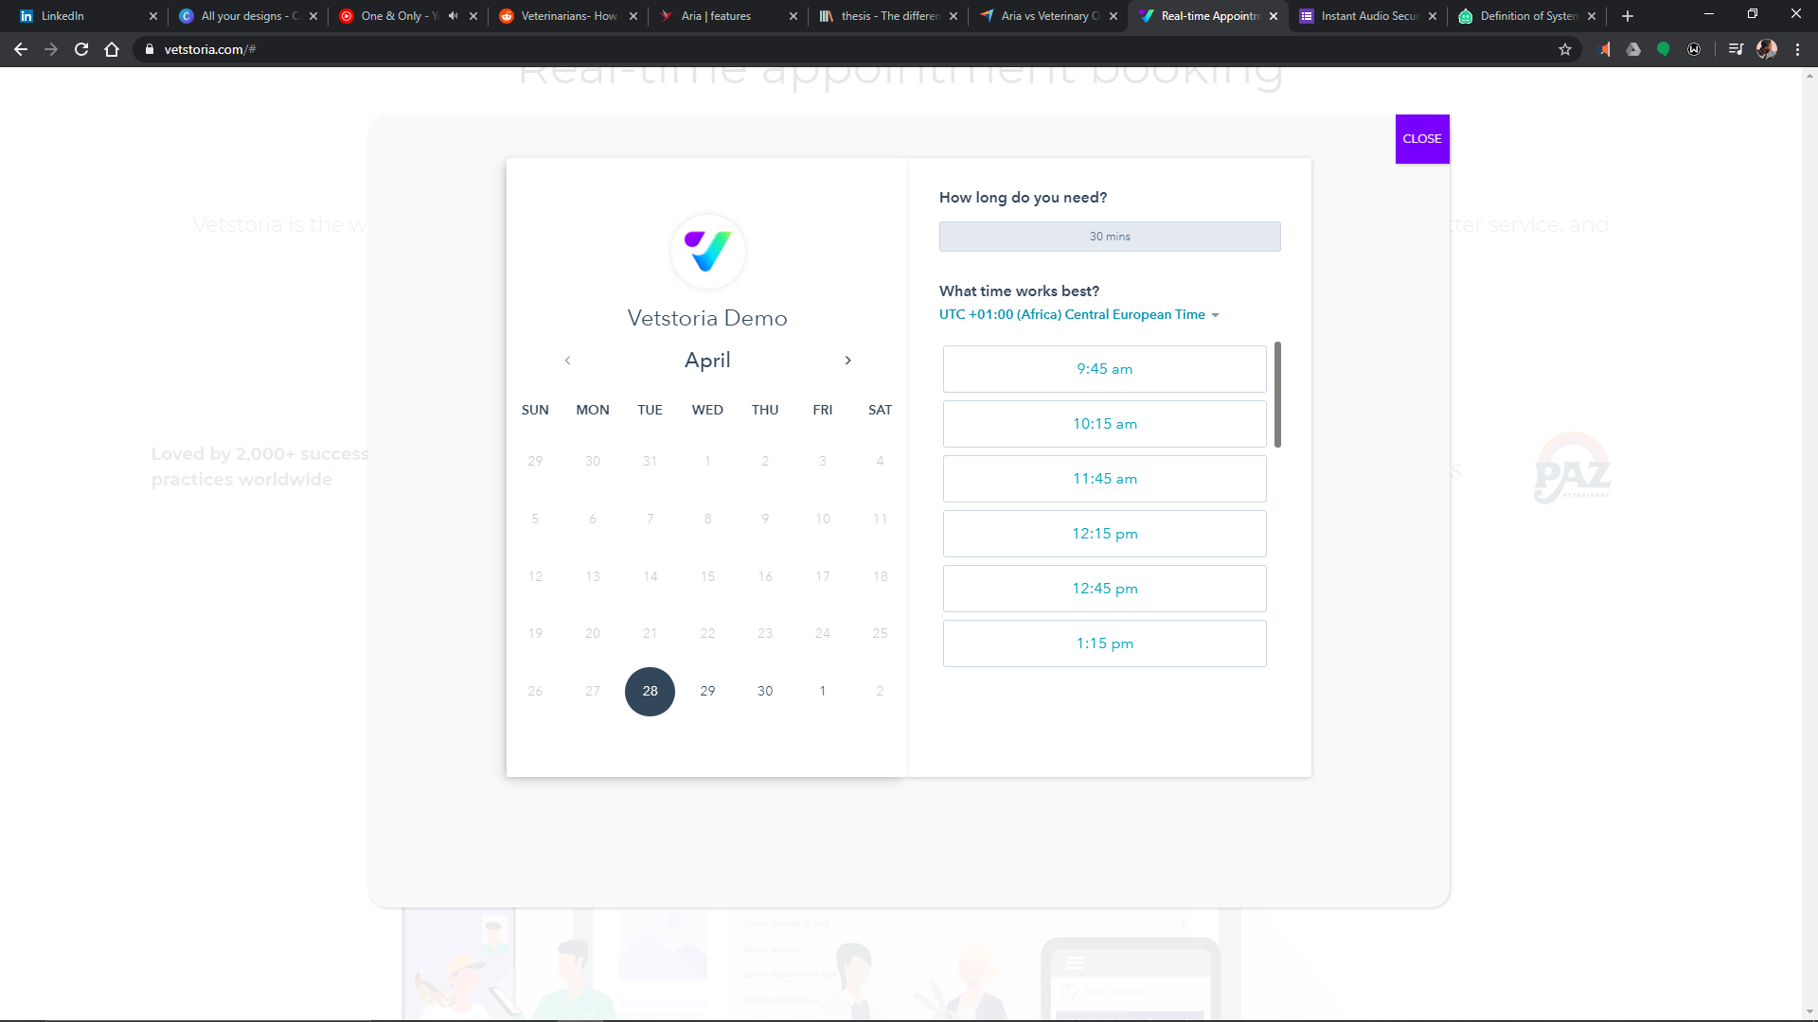
Figure IV: Vetstoria 2.

VitusVet
VitusVet is a web-based practice management solution that enables pet owners and veterinary practitioners to manage pets' medical records, vaccination reminders, scheduling errors, conversation history. It is a practice management tool that helps users manage appointments, medical records and more. (Veterinary Software, 2020)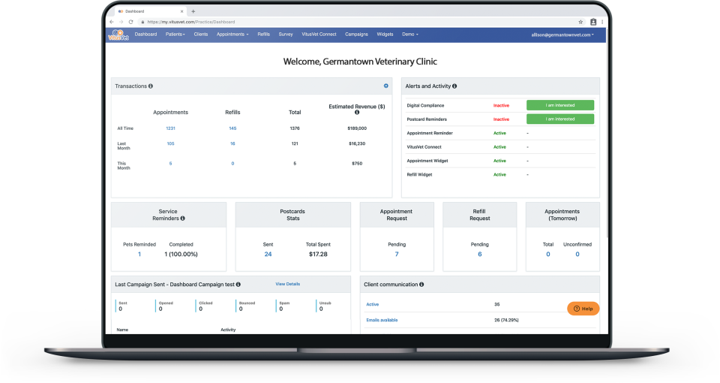
Figure VII: VitusVet.

VetO
VetO is a veterinary app that helps in the need for clinical automation to reduce the Overhead Cost of Clinic. A practice management solution for Veterinary Clinics, EXCLUSIVELY designed for Veterinary Practitioners. (Veterinary Software, 2020).
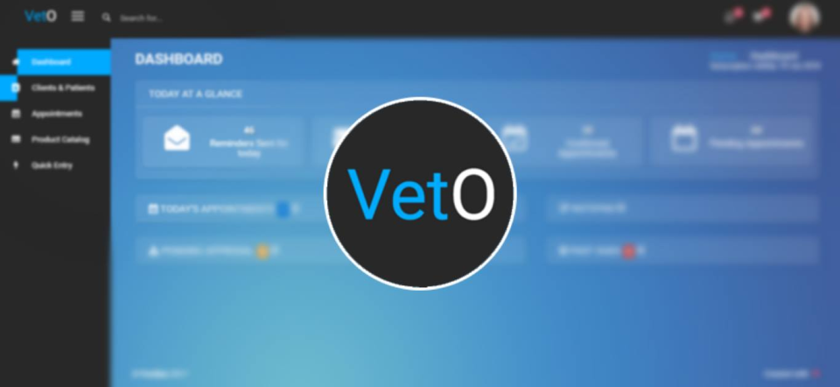
Figure V: VetO 1.
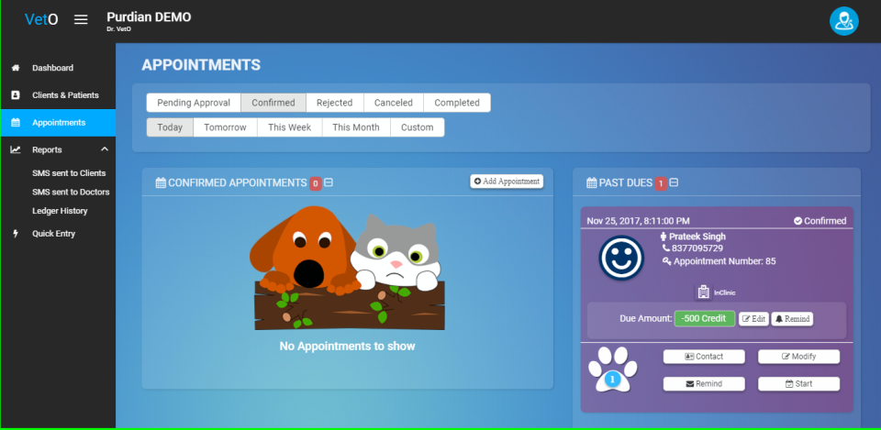
Figure VI: VetO 2.

Differences Between Vetstoria and VetO
Vetstoria | VetO
Independent Veterinary Practices | Prescription Processing
Corporate Veterinary Practices Specialist | Patient Records Management
Table 1 Comparison between two online reservation systems

Similarities Between Vetstoria and VetO
- Both websites provide useful functions such as Appointment Reminders, Appointment Scheduling.
- Both websites are easy to navigate through
- Easy to interact with

CHALLENGES OF EXISTING APPLICATION
For most users at first, the software may be a little confusing. Still, they typically get the hang of it, in this case, the user interface is having a problem. Too many steps to get to one location are also an issue that leaves the user frustrated to use the app next time. Applications like this typically have updates, but they become costly if users need extra assistance or support in setting up items. There is still a lack of written instructional materials/"How to "manuals/function lists.
Nevertheless, people can abuse the booking application, and there will be many users not appearing at the time of appointment. That does not happen based on research and articles. Online reservations are also widely used in human healthcare and other industries. Why would not that work in the veterinary sector?

REQUIREMENT SPECIFICATION

USERS
User needs an android device to access the application.

DEVELOPMENT
- Hardware: a laptop with a total of 4 GB of RAM and 4 GB of usable storage space (500 MB for IDE + 1.5 GB for Android SDK and emulator device image). Microsoft Windows 7/8/10 (32-bit or 64-bit) version. The Android Emulator only supports Windows 64-bit. The total screen size of 1280 x 800.
- Android Studio to install an Android Emulator: to operate the code as a simulator.
- Database: the storage where all relevant system details are processed and retrieved.

USER REQUIREMENT
- How would the user like to book an appointment with their veterinary doctor?
- Given that the online booking system is 24/7, what period are the user would most likely to book an appointment
- Out of 10, how much would the user rate the satisfaction of the current online booking system
- Feedback

SURVEY RESULT
To grasp user requirement, the better choice was to use the survey tool to obtain a user's theoretical viewpoint of when booking an appointment. An online questionnaire was generated using the Google form, 41 responses were obtained from African countries. Here is an overview of this;
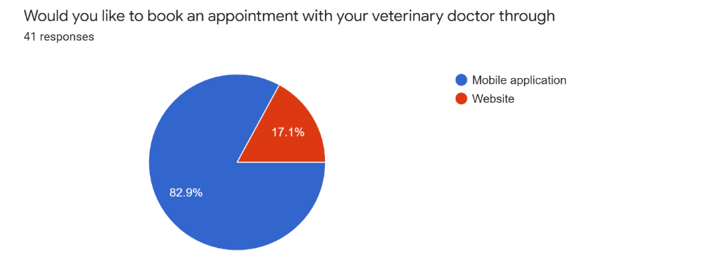
The survey shows that 82.9% of the 41 responses prefer to use mobile application when booking an appointment
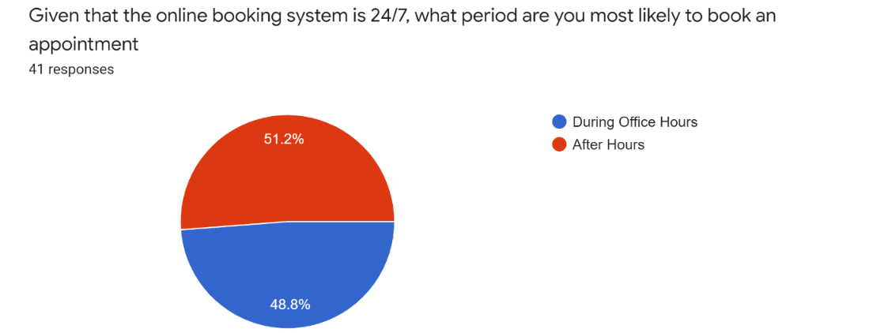
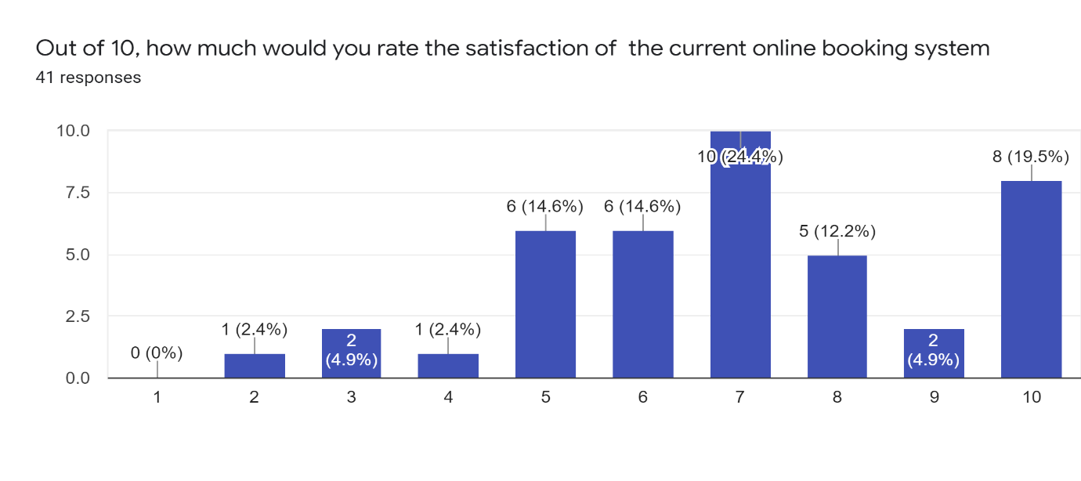
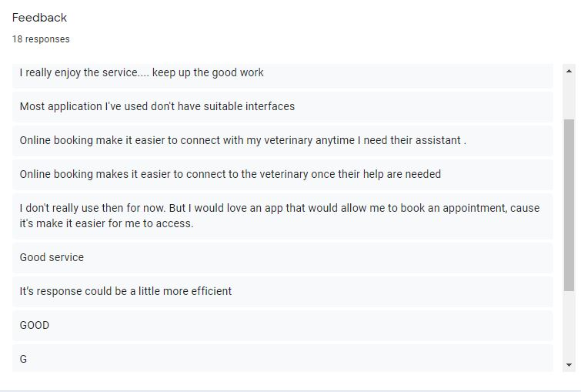
Link to google form survey: https://docs.google.com/forms/d/1uUzxjP0N8k3iIUgmBJ2Anv2c-FZnnnpposZnC4lNF0c/edit?usp=sharing

REQUIREMENT ANALYSIS
The purpose of the requirement analysis is to identify the specific requirement of the booking system, emphasis on the user requirement. Each requirement is defined and documented.

FUNCTIONAL REQUIREMENTS
Functional requirements consist of the system uses and what it provides the users. It comprises the description of the required function and details of the data in the system.
- The system supports users to make, modify, modify, or delete the booking.
- When the user searches for the clinic, the result of the clinic must contain the full information (Address, Ratings, and Price) and as well as the review given by the previous user.
- The search result should enable uses to find the clinic most relevant to their booking option and close to their location.
- The system should accept all kinds of credit or debit cards.
- The system must send a booking verification email after successful payment.
- Each booking should be associated with the booking id.

Non-Functional Requirements
A non-functional requirement specifies the properties of the information system itself. Some of the non-functional requirements for this project are:
Security: Manager and customer representative on duty will be able to log into the system and have access to the reservation/booking system, but access to the various subsystems will be protected by a user log-in screen that requires a username and password.
Availability: The system will be available during regular vet operating hours
Reliability: The performance of the system is consistent according to its specifications
Speed:
- The system should respond to users request within 2-3 seconds
- The system must retrieve information
Usability: The system gives direct input on how real users use the system.
Portability: The system supports every operating system
Efficiency: The system provides appropriate output based on the list of inputs.

System Analysis and Design Phase

USE CASE DIAGRAM
The use case diagram is used to refer to a behavioural diagram that is used to describe a set of actions that the system can perform in collaboration with one or more external system users (actors). Each use case provides some visible and valuable results to the users of the system.
Symbol | Reference Name
 | Actors (User, Doctor, Receptionist)
 | Use case
 | System
<<Include>>  <<Exclude>> | Relationship
Table 2: Use case Diagram Symbols. Source: http://umltutorials.blogspot.com/.
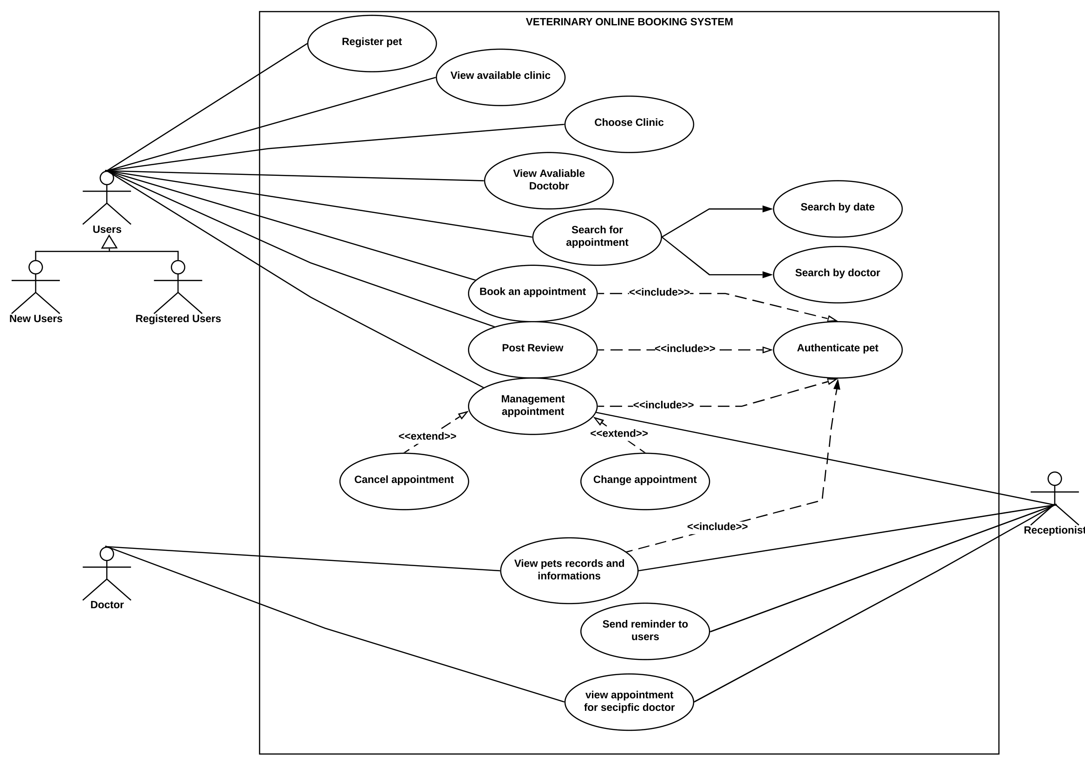
Figure I: Use case Diagram.

SYSTEM ARCHITECTURE
Iterations between Logical and Physical Architecture Model Development of the system through an intermediate model of logical architecture to allocate the elements of the logical architecture model to system elements of candidate physical architecture models (Alan Faisandier, 2020).
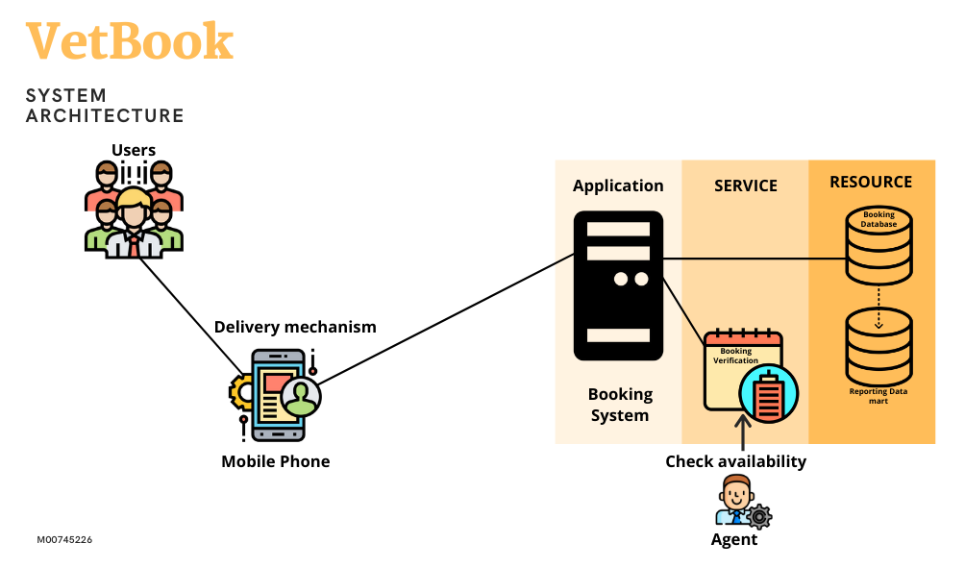
Figure II: System Architecture

ENTITY RELATIONSHIP DIAGRAM
To design a database, there must be a clear understanding of how the business operates so that the design produced will meet user requirements. The Entity-Relationship model allows database designers, programmers and end-users to give their input on the nature of the data and how it is used in the business (Anonymous,2018).
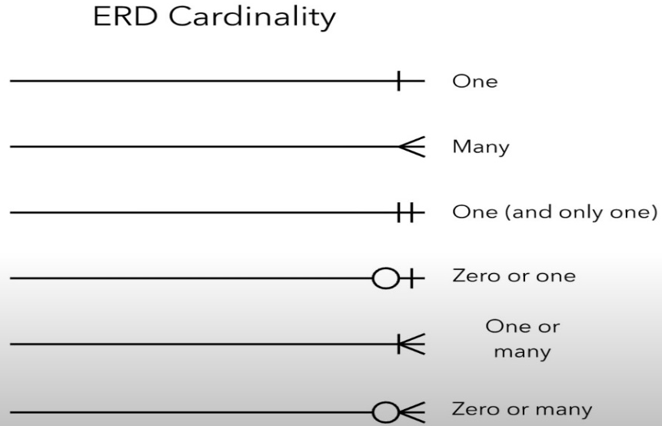
Figure III: ER Diagram Cardinality
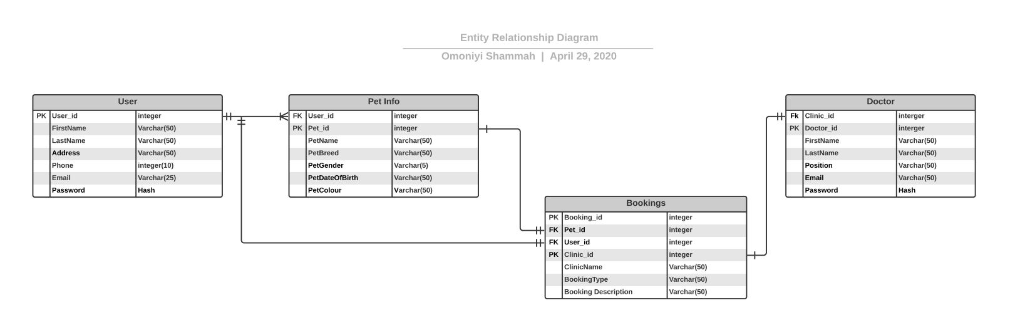
Figure IV: ER Diagram.

STORYBOARD
The storyboard is created to illustrate a user in a visual outline showing all necessary potential steps time- and sequence wise to achieve the desired outcome or solve a problem (Ill Scientia, 2020).
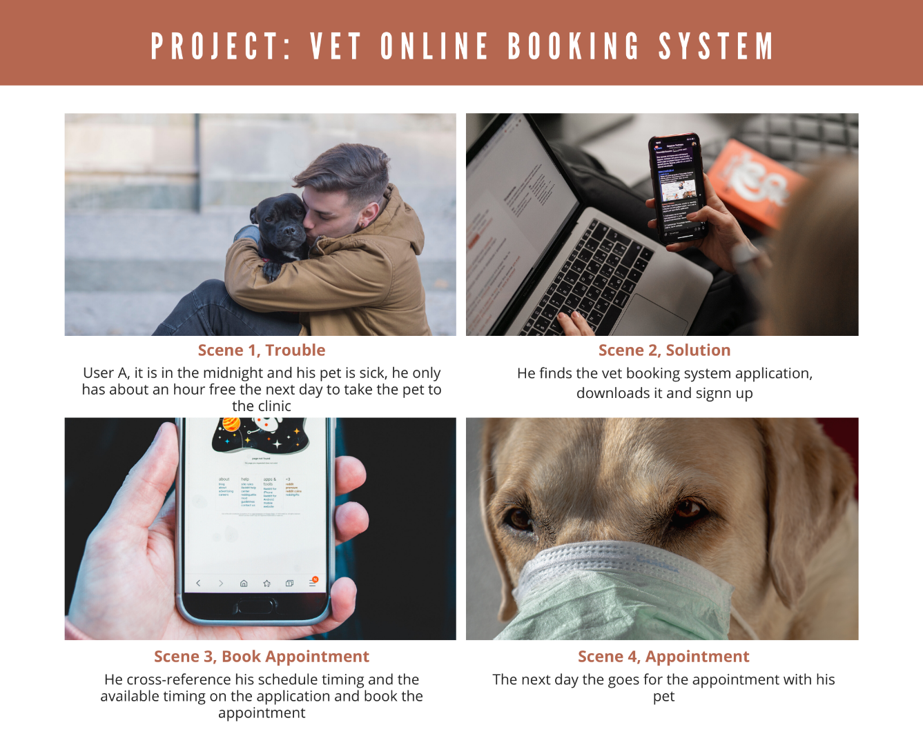
Figure V: Storyboard: VET ONLINE BOOKING SYSTEM

USER INTERFACE
The user interface was designed with adobe XD, all pictures used in the application were downloaded from a free website "unsplash.com" then it went through some evaluation to make some changes

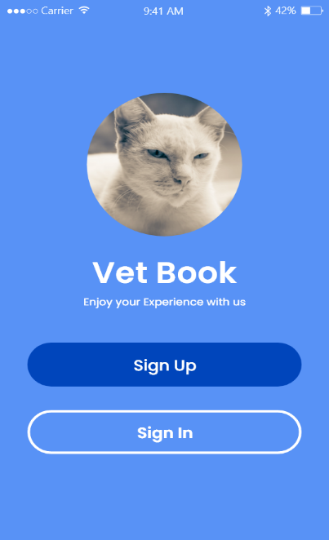
Figure VI: First Page of The Application
The first page of the application was formally where the user can sign up if they are new to the system, and if they already have an account in the system, they can sign in. but it was rectified into the splash screen of the application
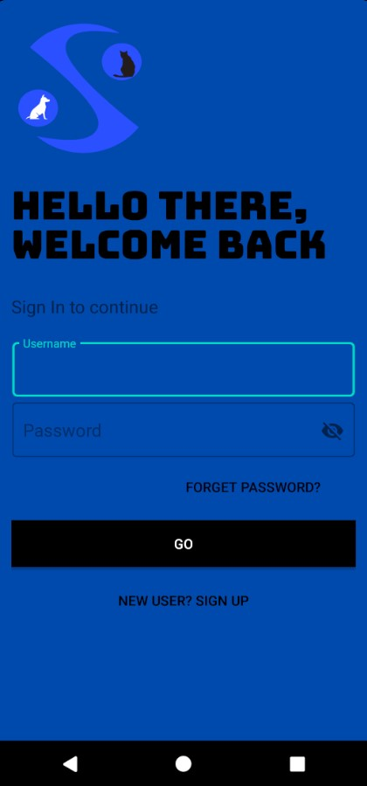
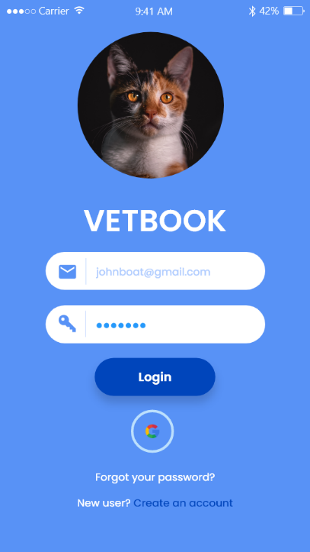
Figure VII: Login Page of The Application
The log-in page is where exiting user inputs their data to access the application. Furthermore, if the users do not have an account in the system, they are required to go to the sign-up page.
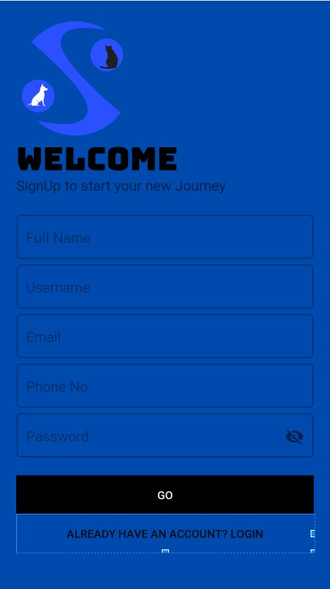
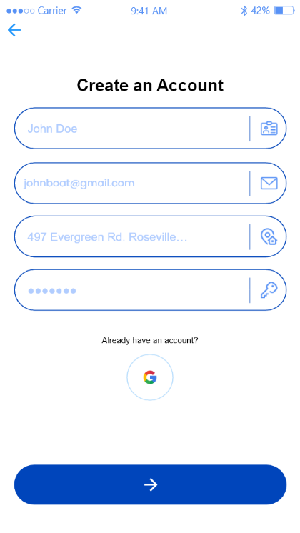
Figure VIII: Sign up Page of The Application.
The sign-up page is where the user independently inputs their data to register and gain access to the application.
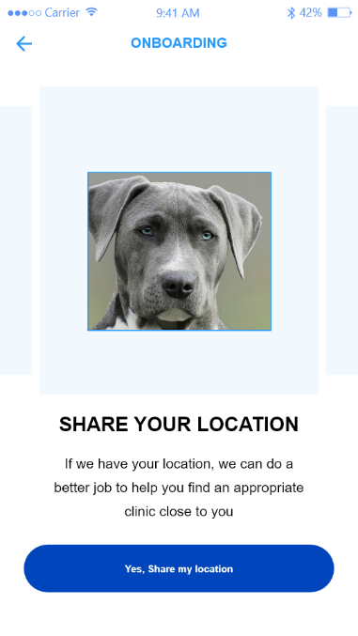
Figure IX: Share Location
The share location page will be using a Google API, which is a way to give the users the location of the closest clinic to them.
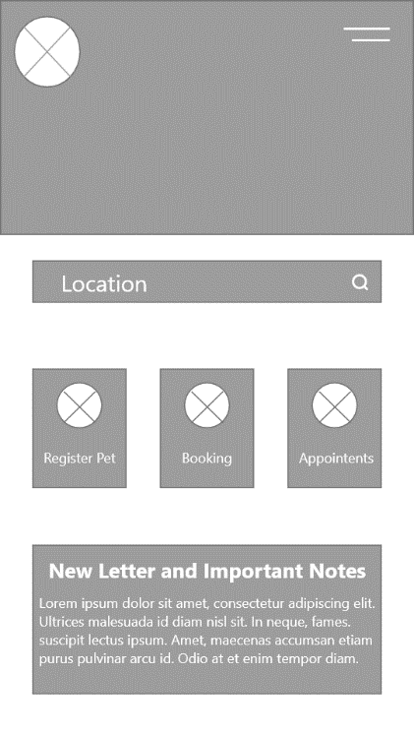
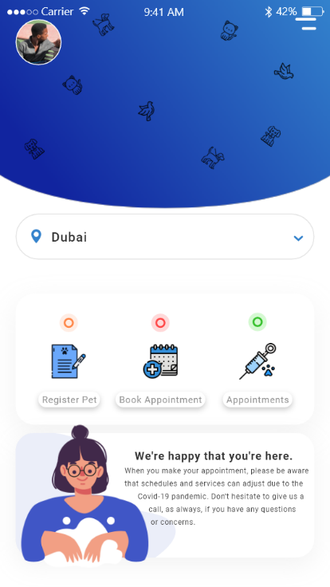
Figure X: The Home Page of the Application
The home page is the page that serves as the starting point of application to give the user the introductory of application. It is also serving as a table of contents for the application.

SYSTEM IMPLEMENTATION AND DEVELOPMENT
This chapter discusses the processes and techniques used in the implementation of the android application, the testing and the evaluation with an emphasis on the user experience domain.
The system implementation is mostly about making and fabricating the system, which involves programming of the source code, testing of each function developed and debugging of the program development (Schmidt, 2013). The primary purpose of writing the program is to ensure that the desired function meet the users need.
The right methods and processes were adopted to create and enforce a program. The Agile software development was applied for the Vet book Program.

FRAMEWORK - Agile Software Development (ASD)
Agile development is a conceptual framework mostly applied in software engineering projects. This type of methodology minimizes risk by developing software in short timeboxes; this is known as iteration, which generally lasts from one to four weeks. There are a few ASD methodologies: Dynamic System Development Model, Crystal Methods and Scrum.

When to Use Agile Model
- When end-users or clients can change the scope of the project.
- When there is no clarity of what the final product of the system will look like.
- When the company hires skilled developers, who can think independently.
- When rapid production is more important than the quality of the product.
The processes of Agile Model are:
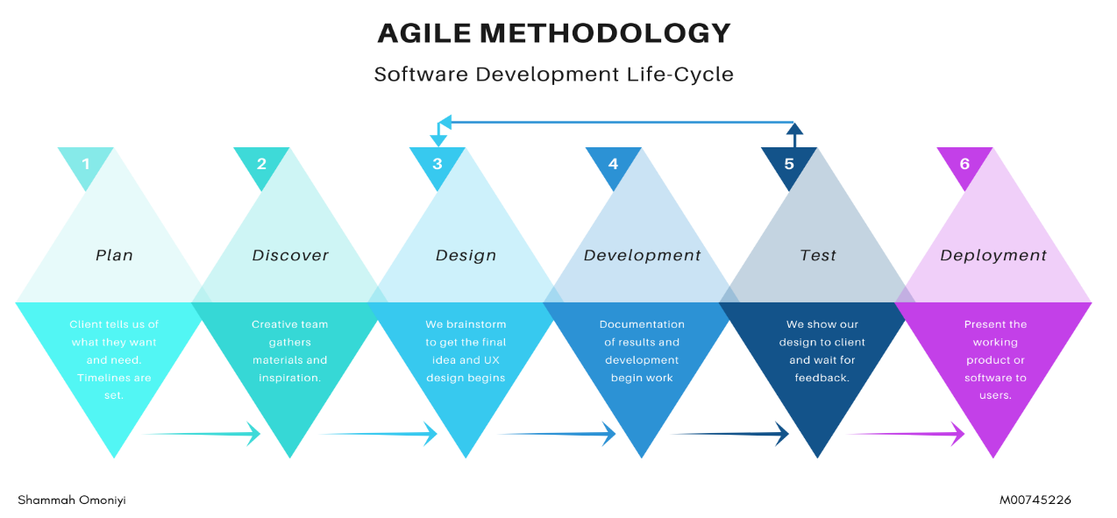
Plan
this phase involves creating the initial documentation of the project's description, objectives and deliverables. Additionally, the software and tools for the development will be documentation.
Discover
In this phase, the requirements are gathered from the previous phase for the creative team to understand user preference.
Design
For the previous phase, after the creative team have understood the user's preference, they brainstorm and develop the UI/UX design.
Development
This process includes concept designs to be translated into real applications, includes programming tools. The execution of this process takes time. This is the most crucial phase of the project.
Test
The developed system is then tested with users of the system to ensure the system meets the requirements.
Deployment
It's the final phase. In this case, the software is deployed on a server so the users can access it. No implementation has been performed in this phase.

Advantages of Agile Methodology
- Its saves time and money
- Quickly identifies any mismatch and improve quality by finding and fixing defects at an early stage.
- Allows for direct communication to maintain transparency
- Changes or new enhancements can be implemented during the development phase.

Disadvantages of Agile Methodology
- Challenging to determine effort estimation at the early stage of software development, this is mostly in bigger and complex projects.
- The methodology pays less importance in designing and documentation
- High chances of getting off-track if requirements are unclear
- Only senior programmers can be making and taking any decision required during the development process.
Agile was chosen so that an effective response can be taking to the changes or feedback from the users quickly without derailing the entire system. Being that the system will pass through the testing phase, the result will make the users happier, being that they were suggesting improvement and involving them throughout the development of the decision process. (What is Agile Methodology? and Why Do We Use It? - VC Web Design, 2020).
The request for a Vet book, requirement, was collected through user research. Functional and non-functional specifications have since been defined and evaluated. Based on the specifications obtained, the framework diagrams have been created to explain the relationships between users and the framework. Two UML diagrams have been developed, namely the Use Case Diagram and the Entity Relationship Diagram. The software was designed after the flows were extracted. When the UI prototypes have been finished, the development phase has started.

IMPLEMENTING THE APPLICATION
As mentioned above, the framework for Vet Book is an android program. It is built up in the Android Studio using the Java Programming Language. When it comes to mobile technologies, Java is said to be Android's preferred programming language. Let us examine the code and design development in a few use cases. The rest of it can be found in the appendix.

Splash Screen
The splash screen is the first screen to appear while the program is lunching. The main activity, which is the first screen to appear when the user launches the application, was used to program the splash screen. The splash screen consists of a window containing three separate animations, an image, a logo, and the name of the application. The splash screen using a thread in onCreate () for a 3 second before going to the next activity.
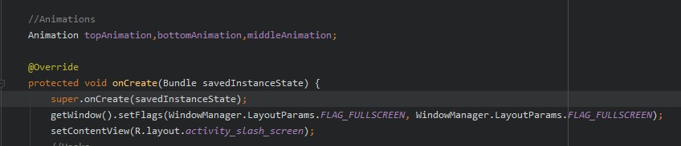
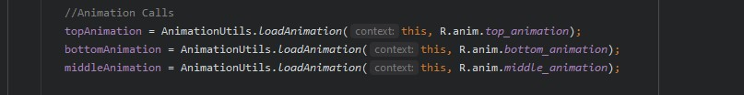
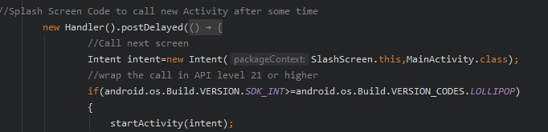
Figure XI - Splash Screen source code

User Sign Up
The following code represents the Sign-up function. A list of fields where the users will fill out their personal details like name, email and password to be store in the database. Depending on the validation and conditions passed in the application, the user details will be stored in the Cloud Firestore. Once the email is verified, the user is fully registered.
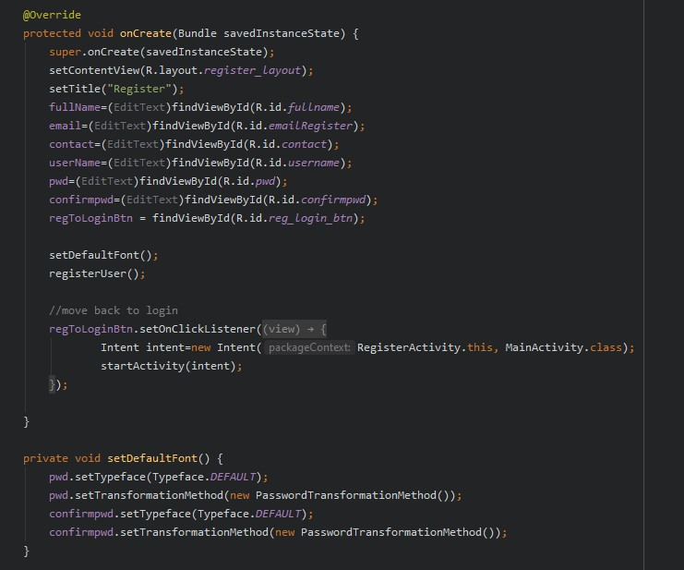
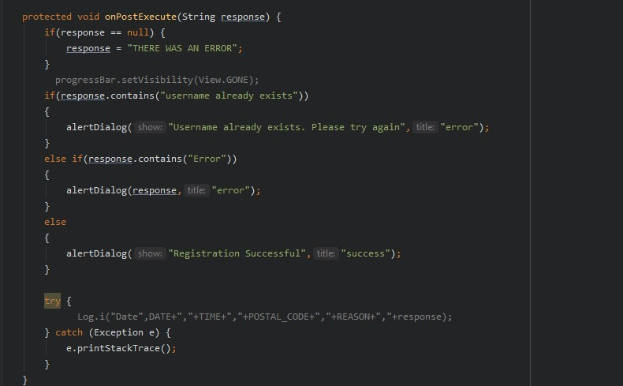
Figure XII - User Sign Up Source code

User Sign In
The Sign In page is where a set of credentials used to authenticate a user in their account. Validation and criteria are reviewed in the application to ensure that the consumer can securely sign into their respective accounts. Firebase Authentication performs the user's log-in process by validating whether the account resides in the database. The following coding is for the feature of the Sign in.
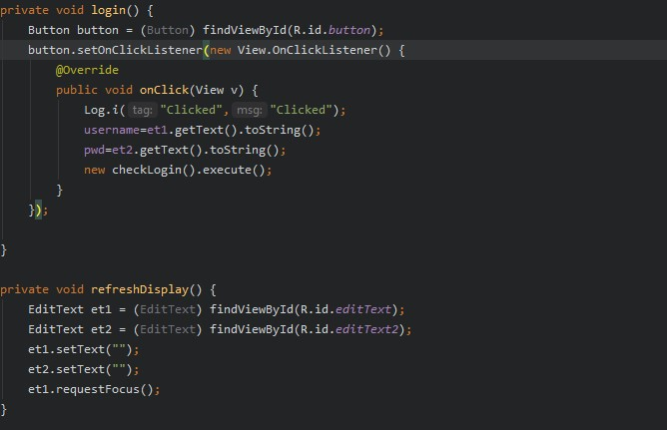
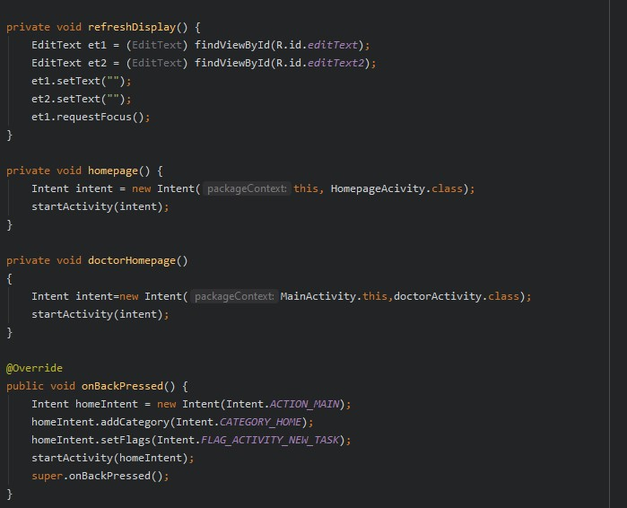
Figure XIII - User Sign in Source Code

User Book Appointment
In the booking of an appointment, users can edit and schedule an appointment. The appointment made by the users is stored in the cloud Firestore. The following code shows the same:
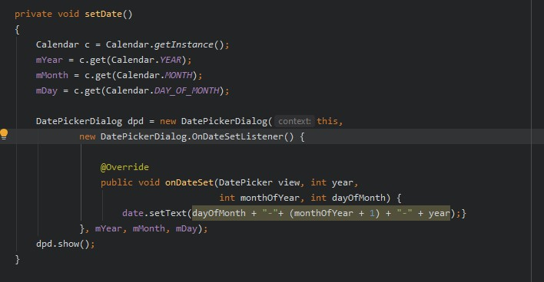
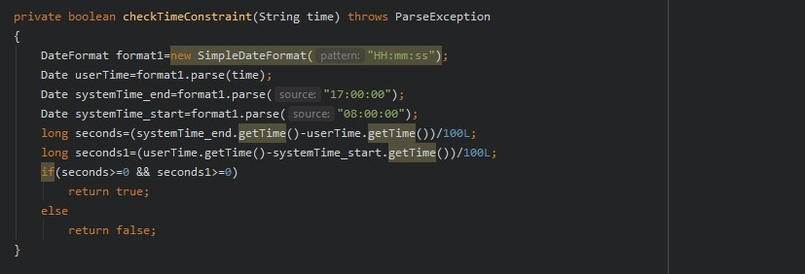
Figure XIV - User Book Appointment Source code

Doctor Retrieving Tasks
In the doctor's page, the data is retrieved from Cloud Firestore immediately the users booking and sent to the doctor's appointment list. If a task doesn't exist in the database, the system displays an empty view. The tasks are also organised based on priority levels informing the doctor about tasks that should be completed first. The following code represents the same.
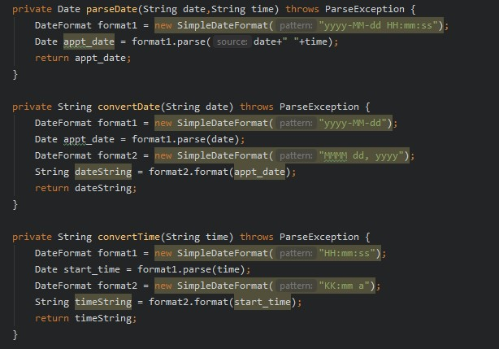
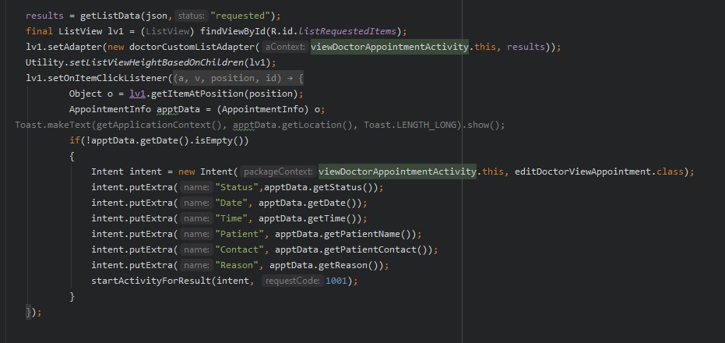
Figure XV - Doctor Retrieving Tasks Source code

Doctor Profile
The Doctor profile displays the details of the user like their name, email, and their available times. These details are extracted "Doctor" and "Active time" data in the Cloud Firestore and displayed. These details are editable and are updated in the database.
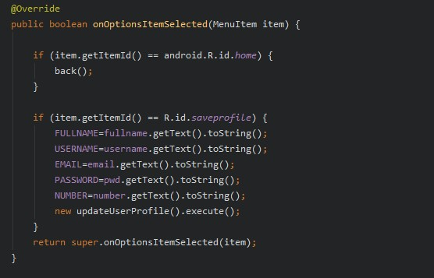
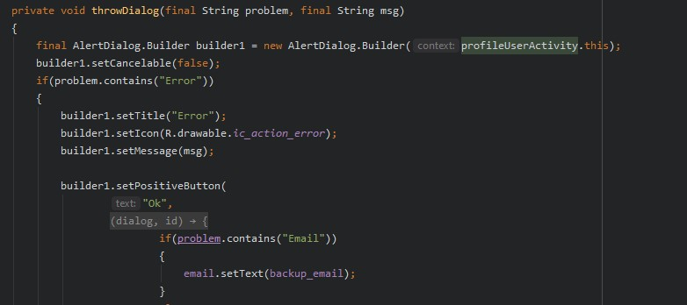
Figure XVI - Doctor Profile Source code

User Profile
The User Profile displays the details of the user like their name, email, phone number, and pet info. These details are extracted from the 'Users' and 'Active Times' collection in Cloud Firestore and displayed. These details are editable and are updated in the database. The user's profile picture is also displayed on the Profile page. A library is used to load and upload the image, which is discussed in the next section. The user profile images are stored on Firebase Storage.
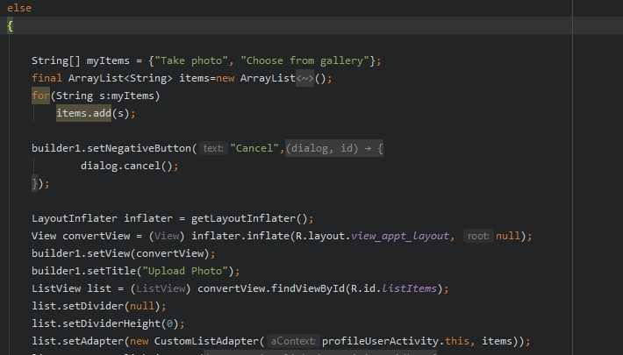
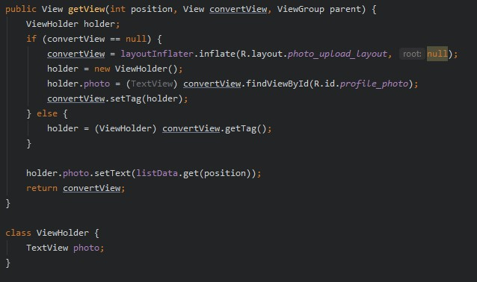
Figure XVII - User Profile Source code

LIBRARIES USED FOR VET BOOK APP DEVELOPMENT
Libraries are a category of non-volatile tools used in applications for different purposes, such as configuring records, logging, defining attributes, classes or styles (Webopedia, 2018). It is also a category of behavioural implementations which are written in terms of the coding language and provide a well-defined framework that invokes behaviours.
Android Studio has several support libraries that support application development. These libraries help with compatibility, debugging, convenience and utility features (Android Support Library, 2019). A variety of libraries have been introduced to support the creation of the Vet book Application. The libraries used are shown in the figure below.
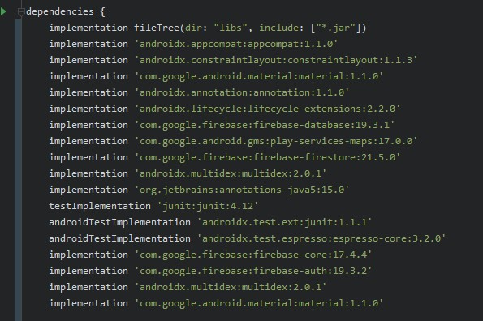
Figure XVIII - The libraries used

JUnit 4 Library
The JUnit Library is a primary tool for writing repeatable programming. This is one of the most prominent and growing libraries used to check the Java Platform for units. It helps developers to write experiments in a far more robust and more straightforward way than other iterations (android Support Library, 2019).

Recycler View Library
The Android Studio Support Libraries provide several user interface support groups (Android Support Library, 2019). The Recycle View Library is one of the libraries used for the Vet Book Application interface. It is included in the Activities and Calendar Pages. The Recycle View class allows you to handle and monitor long lists that can be used by Android versions from and above API level 7.

Card View Library
The Android Studio Support Libraries provide several user interface support groups (Desktop Support List, 2019). Recycle View Library is one of the libraries used for the Vet book application interface. The activities and calendar pages are included. The Recycle View class enables long lists for Android apps from and beyond API level 7 to manage and track.

Circle View Library
The Circle View Library is used to customise pictures and round corners in the Android studio. The profile of the user on the profile page has been used in this library. With the help of this collection, the profile photos were circular in shape. This collection was created by Henning Dodenhof, an accomplished software developer and CTO (Dodenhof, 2017).

Google Material Design
Material Design is a visual language created by Google, "that synthesises the classic principles of good design with the innovation and possibility of technology and science" (Google). Matias Duarte explains "unlike real paper, our digital material can expand and reform intelligently.

Testing and Evaluation
This chapter outlines the systematic review procedures to ensure that expectations for criteria and specifications are met while also explaining the approaches used to determine the efficacy of the web application after its introduction.

Functional Testing
The program was continually checked dynamically along with the implementation of each user experience feature. This enables early detection of bugs that will reduce later discovered high maintenance costs.
With the agile framework, the technical specifications have not been addressed until the narrative on the specific iteration has been applied, and observations have been made on the alternative. This has allowed the developer to refresh their specifications.

Unit Testing
Unit testing is a technique for software testing where specific parts of the program are evaluated for consistency. The behaviours were analysed, and suggestions for improvement needed for more comfortable or more efficient use of the product were collected. Unit testing was significant because the most critical elements could have a considerable impact on the user understanding of the software. For instance, the naming conventions for navigation links and the location of design objects influence how quickly such features can be accessed and utilised.

Testing
the user was contacted, a consent form had been sent to get their signed agreement. After the deal has been made, the application was sent to them. Below are the schedule sheet and consent form.
ID | Name | Position | Status | Contact Details (Mail) | Contacted Date | Consent Form | Recording
U1 | Shalom | Veterinary Staff | Completed | shalomomoniyi@gmail.com | 4/06/2020 | Done | Recorded
U2 | Max | Student | Completed | favormax1@gmail.com | 5/06/2020 | Done | Recorded
Figure XIX - Schedule Sheet

Figure XX - Consent Form

User Tester 1
Task-ID | Use case | Pre-Condition |  |  |  |  | Post-Condition |  | Screen | Result
T-1 | Log-in | Email and password fields are empty |  |  |  |  | Show a notification to enter email and password | Show information about incorrect data and the user shall not get logged in | Log-in | Pass
T-2 | Registration | One or more fields in the form are empty | All the fields are entered, but the email is already registered with the app |  | All the fields are introduced, but the username is already registered with the app |  | A notification to open all areas should be shown, information that says email id is already registered and username is already registered should be shown |  | Registration | Pass
T-3 | Book appointment | SMS contacts and email contacts are set from the contacts setting screen |  |  |  |  | A notification after booking the appointment should be shown, information of the user and their pet should be sent to the doctor. |  | Main screen | Pass
T-3 | Book appointment | User must be on the main page |  |  |  |  |  |  | Main screen | Pass
T-3 | Book appointment | Book appointment |  |  |  |  |  |  | Main screen | Pass
T-4 | Personal info screen | User must be logged in |  | User must be on the profile page |  | All fields are entered | A notification to enter all fields must be shown, |  | Profile Screen | Pass
Figure XXI - tester 1 result

Performance Testing
Performance testing is a method of non-functional testing to see how well the device operates under such operating conditions.
/ms
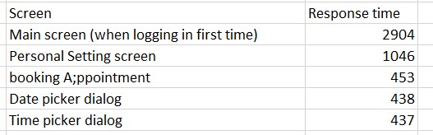
In software engineering, performance testing was necessary before the marketing of the software product. It ensures customer satisfaction & protects an investor's investment against product failure.

Conclusion
This chapter reviews the successfulness of achieving the set objectives and reflects on the author's personal development, in addition to the details of the continuation of the web application.
The project presents an android application which simplify the booking system a user goes through while provides a wild variety of veterinary clinic nearest to them for pet treatment. The application was designed for both veterinary clinics and the users

Reflection
The main objectives defined at the start of the report were:
- Producing a mobile application used for booking an appointment with a veterinary doctor, that's acts as a management system for their learners and their schedule.
- Producing a mobile application to be used by the veterinary doctor to check user appointment and act as a booking management system.
- Evaluating the overall effectiveness of the new system and if it will have a considerable impact on the day-to-day running of the business.
The functionalities required for managing bookings for users and veterinary doctors have still not being completed. However, as future work, all components would be finished like the location activity. From the evaluation and feedback, it is believed that there is considerable interest in online bookings compared to via traditional methods.

Future Work
Several components of the mobile application could be expanded upon and functionality that has been left out due to time constraints
For instance, is the Global Notification System which handles all alerts and reminders for all platforms; for example, when a booking is cancelled all related parties are notified by user preference (text, email) and alerted via a web popup or push notification if being accessed using a mobile device.
Completion of these features, though not necessary, would significantly improve user experience and satisfaction.

Personal Development
The author has had this chance to know more than what was stated in this report. The technology problems have compelled the author to perform analysis, ingest and revitalise various techniques, processes, and procedures for application development.

Reference
Capterra. 2020. Veterinary Software. [online] Available at: <https://www.capterra.ie/directory/30617/veterinary/software> [Accessed 26 April 2020].
VC Web Design. 2020. What Is Agile Methodology? And Why Do We Use It? - VC Web Design. [online] Available at: <http://vcwebdesign.com/uncategorized/what-agile-methodology-why-do-we-use-it/> [Accessed 1 May 2020].
Diagrams, S. and Introduction, U., 2020. An Introduction to Some UML Diagrams. [online] Umltutorials.blogspot.com. Available at: <http://umltutorials.blogspot.com/> [Accessed 1 May 2020].
Singh, S., 2020. Table Reservation System. [online] Slideshare.net. Available at: <https://www.slideshare.net/SagarSingh117/table-reservation-system> [Accessed 15 April 2020].
Agilemodeling.com. 2020. UML 2 Deployment Diagrams: An Agile Introduction. [online] Available at: <http://www.agilemodeling.com/artifacts/deploymentDiagram.htm> [Accessed 11 April 2020].
Scribd. 2020. Ch:2 Literature Review of Hotel Reservation System | Information System | Booking.Com | Free 30-Day Trial | Scribd. [online] Available at: <https://www.scribd.com/document/333361854/ch-2-Literature-Review-of-hotel-reservation-system> [Accessed 1 May 2020].
Quora.com. 2020. [online] Available at: <https://www.quora.com/What-is-a-computer-based-information-system> [Accessed 1 May 2020].
Kenyaplex.com. 2020. List FIVE Advantages of a Computerized System Over A Manual System. [online] Available at: <https://www.kenyaplex.com/questions/50494-list-five-advantages-of-a-computerized-system-over-a-manual-system.aspx> [Accessed 1 May 2020].
Nurmela, M., 2020. 4 Reasons Why to Offer Online Booking for Your Veterinary Clients | Provet Cloud. [online] Provet.info. Available at: <https://provet.info/blog/4-reasons-offer-online-booking-veterinary-clients/> [Accessed 1 May 2020].
2020. [online] Available at: <https://www.youtube.com/watch?v=QpdhBUYk7Kk> [Accessed 9 April 2020].

Appendix

Appendix A
PROJECT MEETING LOG ITX 3999

NAME: OMONIYI SHAMMAH
STUDENT NUMBER: M0075226
SUPERVISOR: MR. Judhi Prasetyo
DATE | COMMENTS | SUPERVISOR'S SIGNATURE
23/02/2020 | First Project proposal feedback
24/02/2020 | Second Project proposal feedback
30/04/2020 | Interim draft (remotely)
17/06/2020 | Overview of coursework requirement. (remotely)
17/06/2020 | First Artefact demo (remotely)
02/07/2020 | Second Artefact demo (remotely)

Appendix B

Consent form

Declarative form

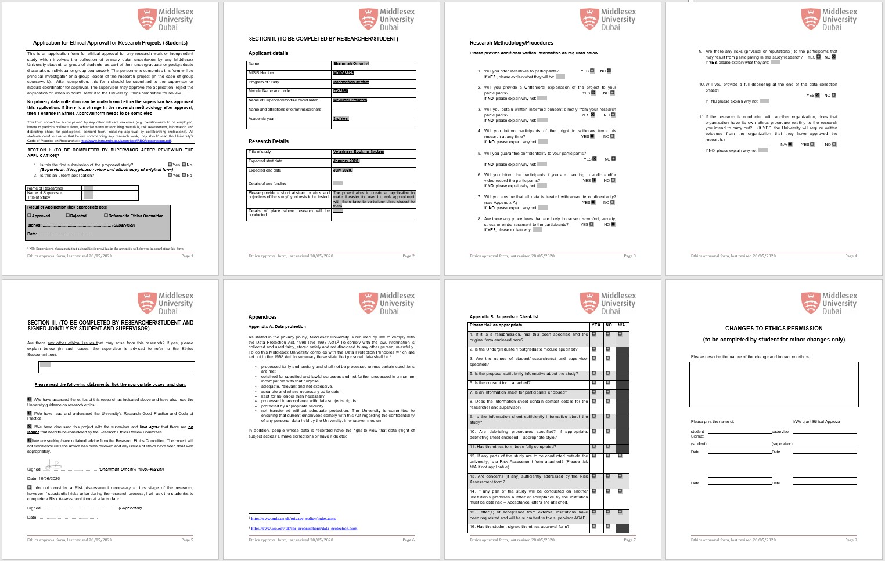

The Circle View Library is used to customise photos and round corners in the Android studio. The profile of the user on the profile page has been used in this library. With the help of this collection, the profile photos were circular in shape. This collection was created by Henning Dodenhof, an accomplished software developer and CTO (Dodenhof, 2017). Android Studio has several support libraries that support application development. These libraries help with compatibility, debugging, convenience and utility features (Android Support Library, 2019). A variety of libraries have been introduced to support the creation of the Rise Application. The libraries used are shown in the figure below. Implementation of the web application, with an emphasis on the user
experience depauperates online. Online booking systems supports most of the phases of making a reservation
and customers can directly make a secured payment to confirm their reservation (Land Vogt,
2004).
2.1 Tools and Technology

