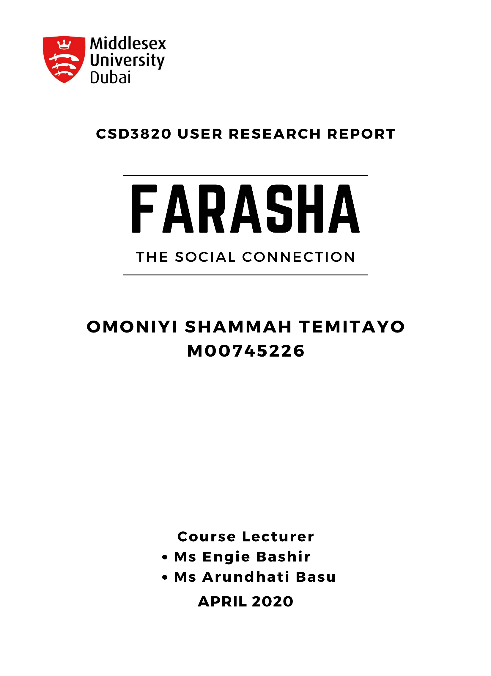
Table of Contents
TABLE OF FIGURE 2
1 INTRODUCTION 3
2 METHODS 3
2.1 STORYBOARDING 4
3 CONCEPTUAL DESIGN 6
3.1 OBJECT-OPERATION ANALYSIS 6
3.2 CONCEPTUAL MAP 6
3.3 SKETCHES 7
4 PROTOTYPING 9
4.1 LOW-FIDELITY 9
4.2 MID-FIDELITY 10
4.3 VALIDATION 11
4.4 HIGH-FIDELITY 11
4.5 VALIDATION 12
5 CONCEPTUAL MODEL 12
5.1 OBJECT-OPERATION ANALYSIS 12
5.2 CONCEPT MAP 13
5.3 SKETCHES 14
6 DETAILED MOCK-UP 15
7 DISCUSSION 17
8 REFERENCE 18
9 APPENDIX 20
9.1 Primary user Persona 20
9.2 Primary user Journey map 20
9.3 Primary user stories 21
9.4 Primary user Scenarios 21
9.5 Sketches 21
9.6 Mid-Fidelity Wireframe 27
9.7 High Fidelity Wireframe 31

TABLE OF FIGURE
Figure I Method used. 4
Figure II Idea-stage of the storyboard 5
Figure III Communication with people with similar interest storyboard 5
Figure IV Filtration of fake news storyboard 6
Figure V Privacy / security storyboard 7
Figure VI Full Conceptual Map 8
Figure VII Crazy 8 voting 9
Figure VIII Prototyping Stage 10
Figure IX added Forum page 10
Figure X Forum outcome 10
Figure XI Voted Forum Page 10
Figure XII Discover Friends sketch 11
Figure XIII Discover Friends Low fidelity 11
Figure XIV Discover Friends Low fidelity 12
Figure XV Discover Friends Mid fidelity 12
Figure XVI Forum Low fidelity 12
Figure XVII Forum Mid fidelity 12
Figure XVIII Discover Friends Mid fidelity 13
Figure XIX Discover Friends High fidelity 13
Figure XX Forum Mid fidelity 13
Figure XXI Forum High fidelity 13
Figure XXII OOA TABLE. 14
Figure XXIII Find Friend Section 14
Figure XXIV All Voted Sketch 15
Figure XXV High Fidelity Explore page 16
Figure XXVI High Fidelity Find Friend Loader page 16
Figure XXVII High Fidelity Find Friend page 17
Figure XXVIII High Fidelity explore nav-bar 17
Figure XXIX High Fidelity Forum page 18
Figure XXX DETAILED MOCK-UP 18

INTRODUCTION
Human-centred design is an approach used to understand the concepts and techniques relevant to the user's experience. To build a design that incorporates the user 's perspective into the application and service design (Technology.tki, 2012). According to the timeline of the project, the design generally consists of three phases, the user research, prototyping and designing, and evaluation of the application. The report will be explaining phase 2 (prototype and design). The prototype and design stage of the Farasha application prototype is to create a social connection mock-up design that solves the pain points of the personas identified in the user research (Phase 1).
Dubai has established itself as a major cosmopolitan hub in the world through its free and liberal environment in the UAE, which is supposed to allow making friends essential. However, according to (World Population Review, 2020), in a total population 2,504,000 in 2016 the population of Dubai comprises of only 15% of native Emiratis residents, the remaining 85% of whom are expatriates. Due to the diversity of the population (nationality), and language barrier (Arabic, English, Hindi, Urdu, and others), which leads to a communication gap in the sociability between the people. Unfortunately, due to limited resources (cost, a high-grade system to run the application, high-grade developers), Farasha decided to place its focus on the future of Dubai, "the student".
According to (the media lab, 2019), the internet penetration in the UAE is reported to be 99% of the total population of 9.61 million people, where 9.52 million people are active internet users. With the increased usage of internet in Dubai, the Farasha team decided to build a social connections application that helps bring together students of different nationalities with a similar mindset or personalities.
The result derived from the user research (phase 1) such as personas, user's scenario, users journey map, users' story and others helped in deriving the goals and objectives. While conducting the user research in phase 1, 3 personas were derived, The primary persona, Ayisha Sara and the secondary personas, Mohammed Khalid and Eliza Mirinda. The user's scenario and the user's journey map were used in creating a storyboard for the prototype and design phase. Refer to appendix for the primary persona Ayisha Sara's user scenario, user story, and user journey map.
The objective of Farasha in this phrase is to develop a conceptual map of the system, create a storyboard, conduct user testing for the storyboard, develop a low-fidelity model (Sketching), develop the mid-fidelity prototype, and develop a high-fidelity model.

METHODS
For the methods used for phase 2, the team used the opportunities derived from the user research to create a storyboard, conceptual map, wireframe and prototype. The image below illustrates the flow of the methods used for phase.
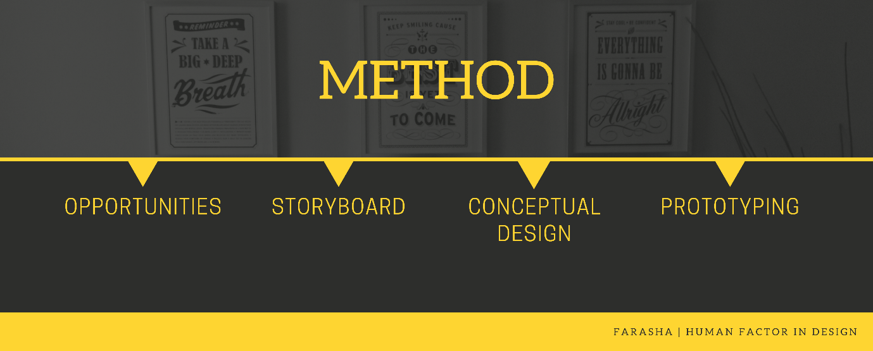
Figure I Method used.
From phase 1 journey map (Refer to appendix to see journey map), the team was able to derive six opportunities from the personas pain-point listed below:
- Structured system security
- Unfiltered fake news.
- Blocking content theft
- Share large files (up to 100gb.)
- Block negative comments.
- Privacy.

STORYBOARDING
The team identified the three core features of the application to create an illustration of the user in a visual outline showing all necessary potential steps time- and sequence wise in order to achieve the desired outcome or solve a problem (IlluScientia, 2020).
From the identified features (connecting with people with similar interest, filtration of fake news, and privacy), the team went through two stages to design the storyboard (idea-stage and full stage). The early stage is a sketch of the storyboard on paper to get a feel of the script. For the full stage, the sketch was redesigned on Canva.com. The image below shows the idea stage of the storyboard.
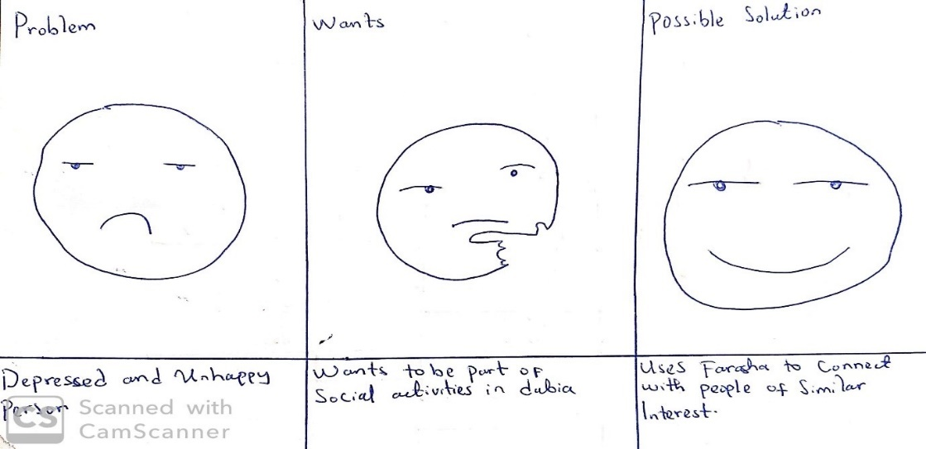
Figure II Idea-stage of the storyboard
For the full stage, the first storyboard examines the communication with people with similar interest aspect of the application where a friend tells his lonely potato friend about Farasha.
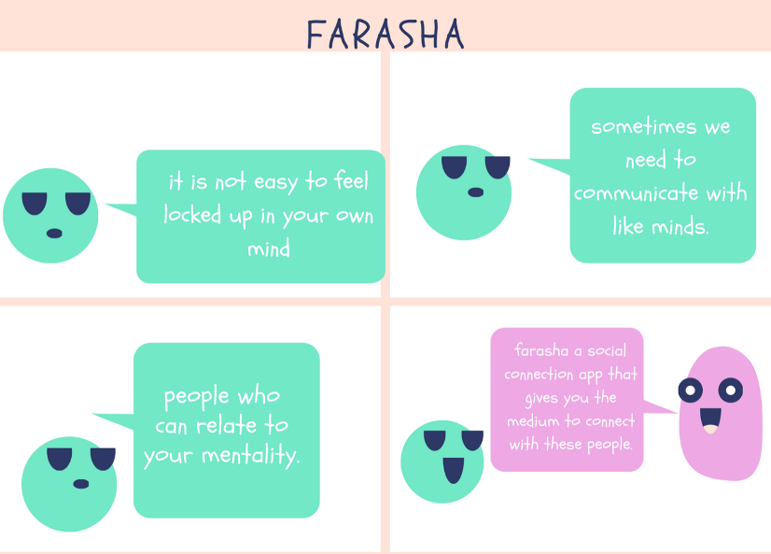
Figure III Communication with people with similar interest storyboard
As can be seen, almost immediately, this storyboard takes a minimalistic approach to its layout and the information it provides. The conversation describing the flow of the story and other activities are kept to a minimum with the only necessary information in order to convey the information effectively.
For the second storyboard, it examines the filtration of fake news that the application provides.
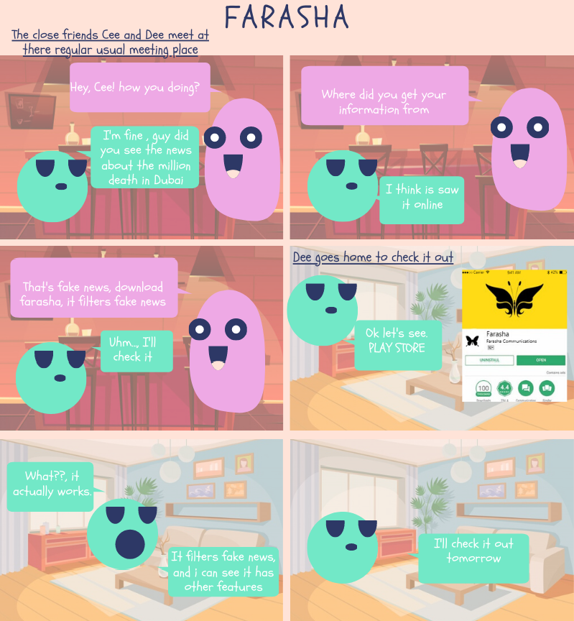
Figure IV Filtration of fake news storyboard
The user is shown frame-by-frame the order in which events took place and what the user pain-point and the solution applied to counter the problem. The flow of the story was also described using the conversation of the user illustrated in the storyboard.
The third storyboard examines the privacy aspect of the application following the same general idea of the first storyboard, where it takes a minimalistic approach to its layout and the information it provides.
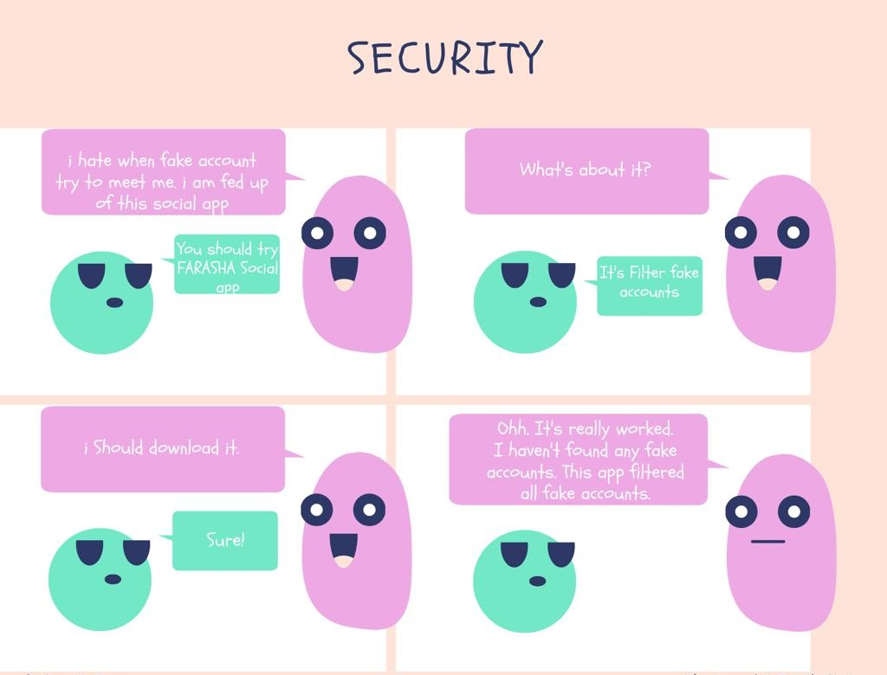
Figure V Privacy / security storyboard
The testing of the storyboard went smoothly with all four participate in the test having understood the storyboard.

CONCEPTUAL DESIGN
The conceptual design is where the broad outline of the application; its function and form were articulated for the user to understand (Johnson and Henderson, 2013). The conceptual model contains the object-operation analysis and the conceptual map.

OBJECT-OPERATION ANALYSIS
An object-operation analysis is an essential element of a conceptual model that displays the application's user-visible object types, the attributes and the user operations of each object type (Johnson and Henderson, 2013).

CONCEPTUAL MAP
A conceptual map was derived for the objects, which depicts the connection and relationship between them. Explore / culture being with the most associated entity. The conceptual map was created using the mural board
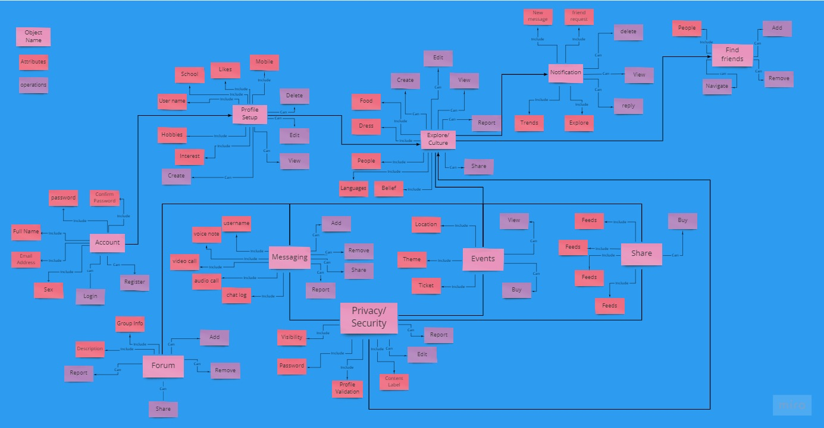
Figure VI Full Conceptual Map

SKETCHES
The team used a quick sketch exercise to sketch eight distinct ideas of each object from the conceptual map in eight minutes (crazy 8's design sprint method). The goal was to push beyond the first idea of the application and to generate a wide range of screens that would best solve the user's problem. From the sketches, the best was selected through voting per object, putting into consideration the user mental model, which was then passed onto the low-fidelity stage. Below are some of the object sketches and the voted sketches are checked.
Page Name | Crazy 8 Sketches
Explore |   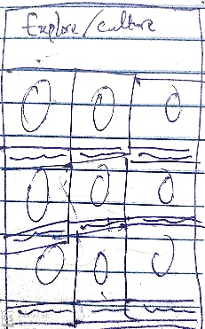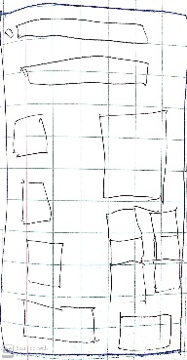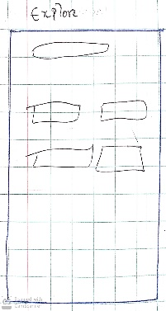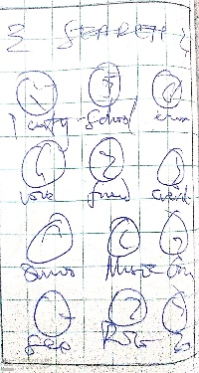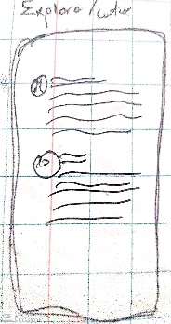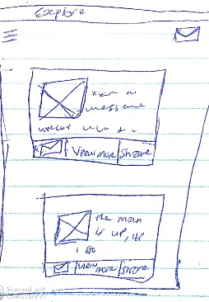
Discover Friends | 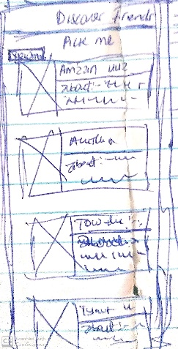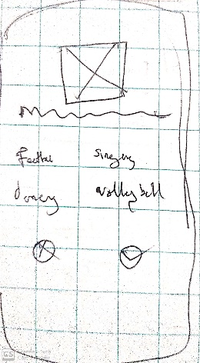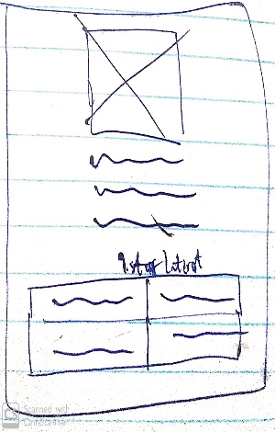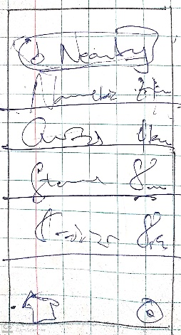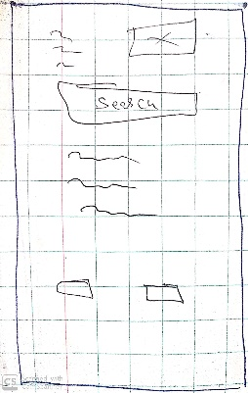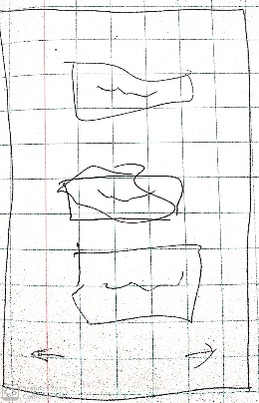
Forum | 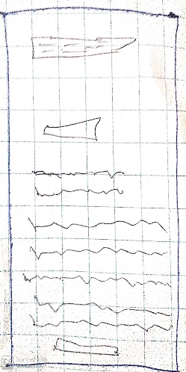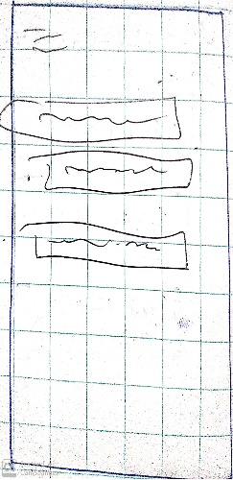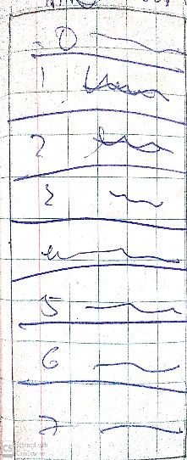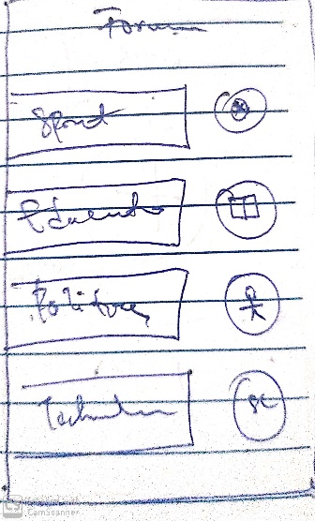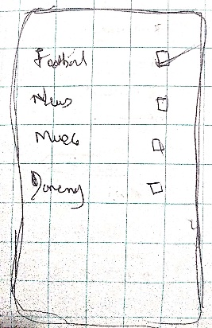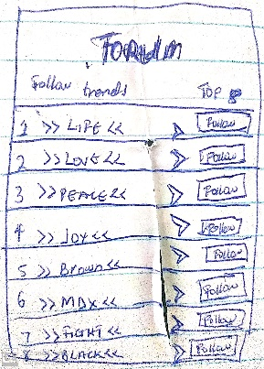
Figure VII Crazy 8 voting

PROTOTYPING
The wireframes were created, and the design deliverable was interactive. While prototyping with wireframes, the team uses the low-high fidelity as it helps to add clarity to the project idea (Chris Myhill, 2020).
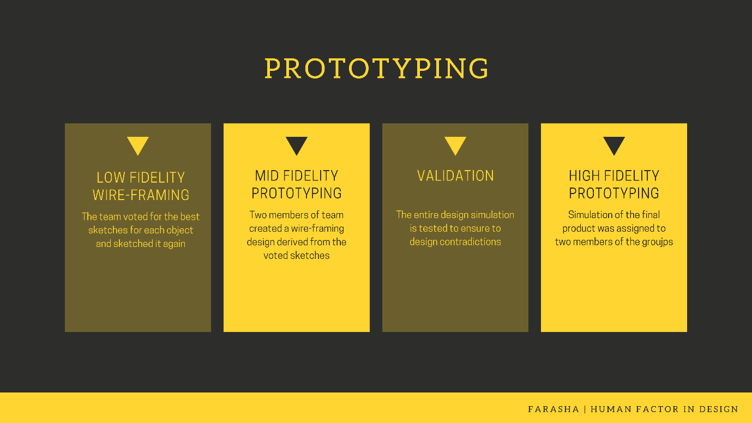
Figure VIII Prototyping Stage

LOW-FIDELITY
In the case of the sketch, several more sketches were selected since some of the voted sketches did not satisfy the attribute's requirements. So, the design was merged with other sketches, but the overall sketches still followed the voted design pattern.
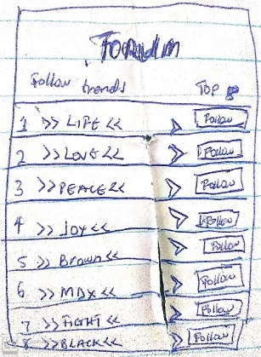  Figure IX added Forum page | 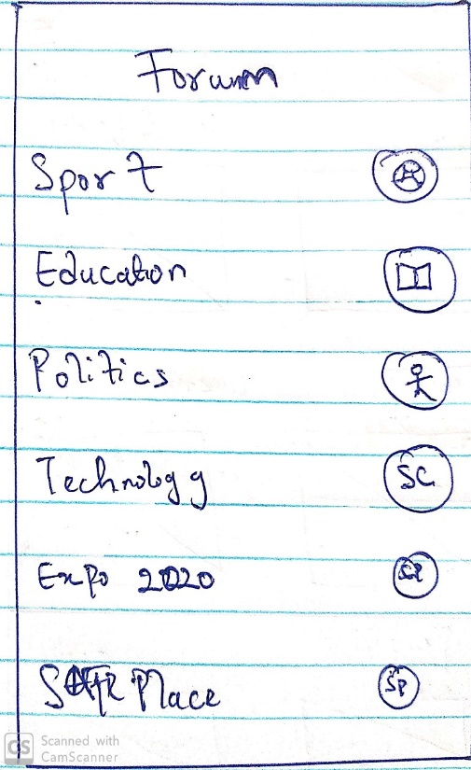  Figure X Forum outcome
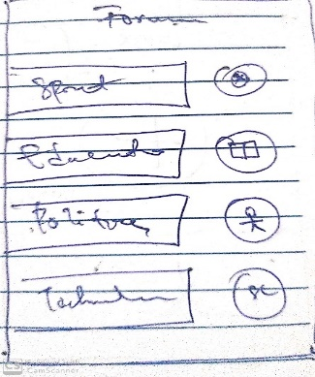
Figure XI Voted Forum Page

The image above shows the merging that took place during the low-fidelity stage in order to meet the attribute requirement better. The team compared the two before the necessary details, which explained the operation and attribute of the forum, were taken out and placed in the chosen sketch. As a result, the low-fidelity wireframe does not look like a sketch.
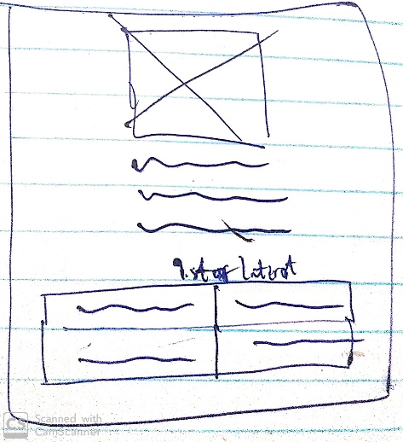  Figure XII Discover Friends sketch | 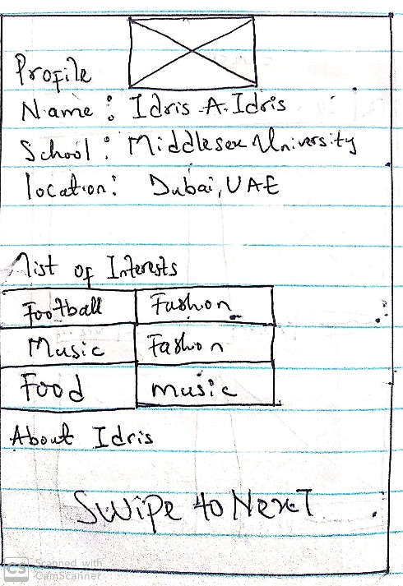  Figure XIII Discover Friends Low fidelity

The text was written to understand the low-fidelity wireframe better while the swipe to next to show that the user can swipe to the next user.

MID-FIDELITY
Low-fidelity was improved in order to derive the mid-fidelity, which included a more accurate representation of the layout, a detail specific to the components, the differentiation of text and buttons. The use of only black, white and different shades of grey. To develop this stage, Figma was used to aid the collaboration of the team but, not all members of the team are designers, so the task was assigned to the two designers of the team (Shammah and Fiyifoluwa). The figures below show some the screen created in the mid-fidelity stage compared to the low-fidelity stage.
 | LOW-FIDELITY | MID-FIDELITY
DISCOVER FRIENDS | 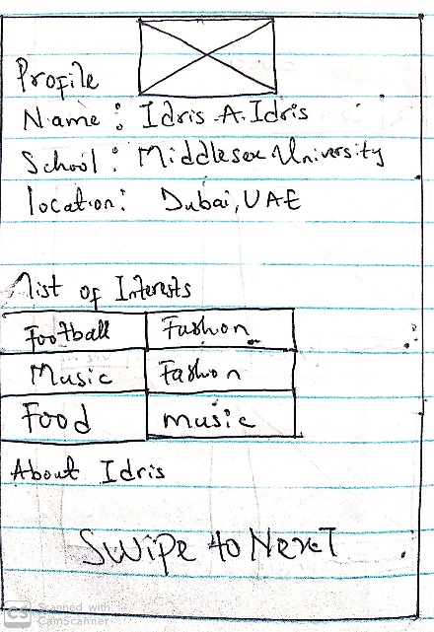  Figure XIV Discover Friends Low fidelity | 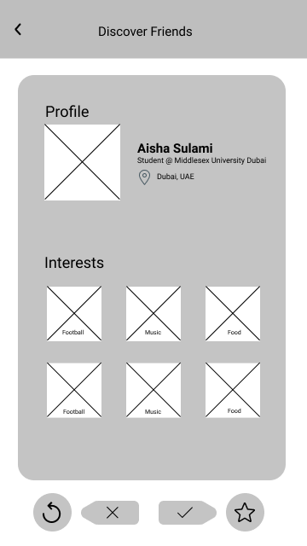  Figure XV Discover Friends Mid fidelity
FORUM | 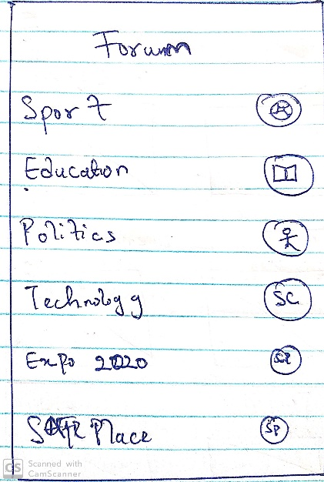  Figure XVI Forum Low fidelity | 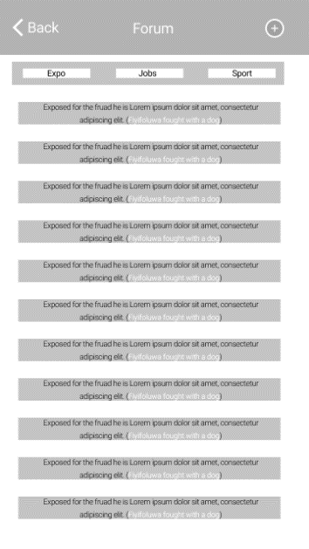  Figure XVII Forum Mid fidelity

VALIDATION
The team members not included in the mid-fidelity design tested to find any fault in the design. To make sure it was easy to use and find the functionality and if there was any missing content.

HIGH-FIDELITY
After validation, the team's designers began designing high-fidelity. They were derived from mid-fidelity, which included the implementation of pixel-specific design layouts, grid system, actual images, colours, and little placeholder text. The figures below show some the screen created in the high fidelity compared to the mid-fidelity stage.
 | MID-FIDELITY | HIGH-FIDELITY
DISCOVER FRIENDS | Figure XVIII Discover Friends Mid fidelity | 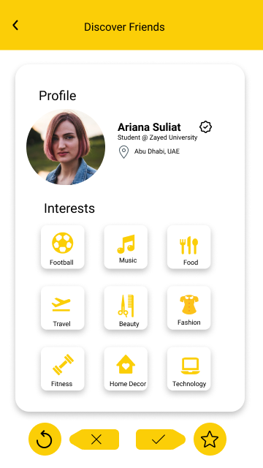  Figure XIX Discover Friends High fidelity
FORUM | Figure XX Forum Mid fidelity | 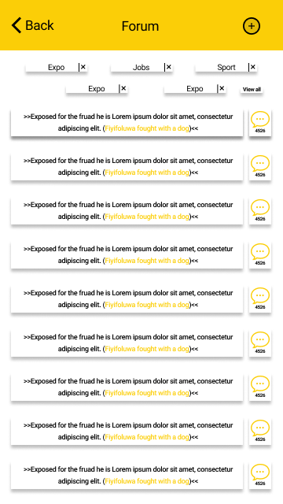  Figure XXI Forum High fidelity

VALIDATION
For high-fidelity user testing and evaluation, this will be carried out in phase 3 of the report.

CONCEPTUAL MODEL

OBJECT-OPERATION ANALYSIS
The objects such as Explore/ Culture, Forum, and Find Friends are included (see Figure VII). Non-tasking objects were excluded, such as a database, and text string as there was no need for such. Attributes of the forum, for example, has News and Chat has the team wanted the user to discover these essential attributes. Furthermore, the operation of the forum object is that the user will be able to Add, Remove, Comment, Share and Report. The operations linked to implementation, such as loading of databases and change mode, were not included in the object-operation analysis table.
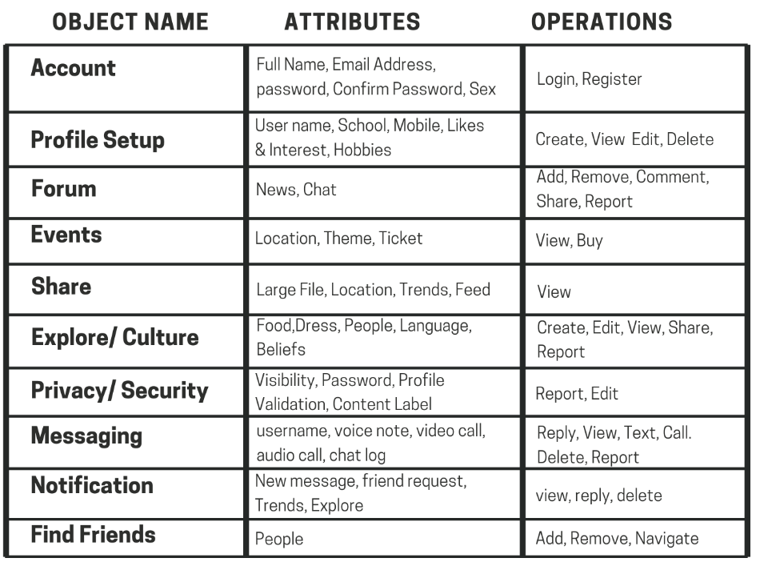
Figure XXII OOA TABLE.

CONCEPT MAP
One of the essential objects in the concept map is the find friend object which can be seen in the figure below. It consists of all the features related to the discover friends screen, which represent all the operation need for the user to find or discover new friends. This object is also connected to the main object "Explore/ culture". The find friends object has just one attribute and three operations. The red represents an attribute, and the purple represents the operations.
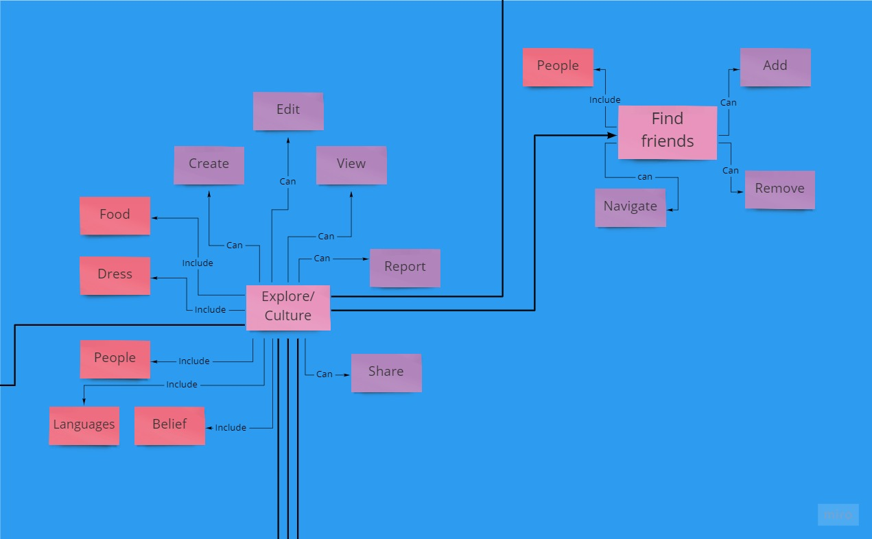
Figure XXIII Find Friend Section

SKETCHES
From the crazy 8, ten sketches were voted for per the object. Below are all the sketches.
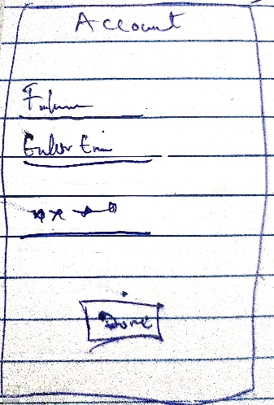 | 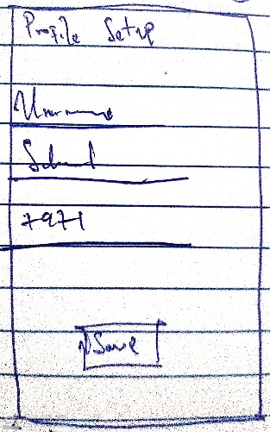 | 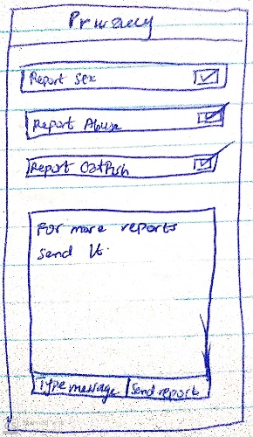 | 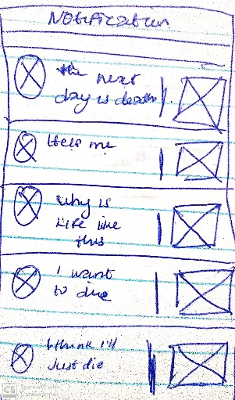
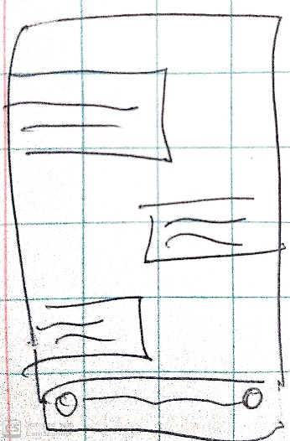 | 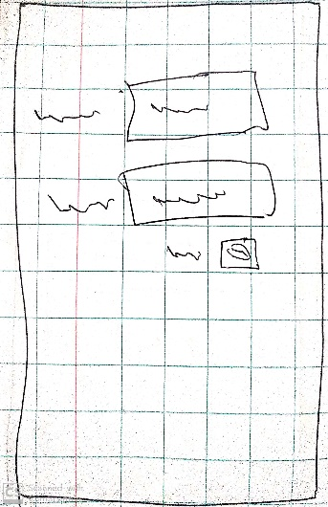 | 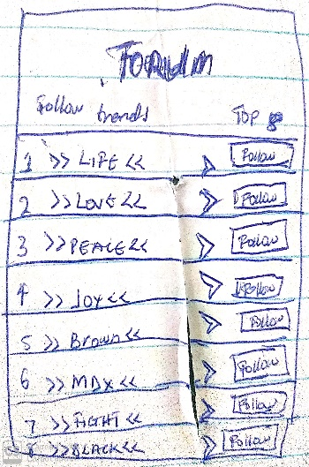 | 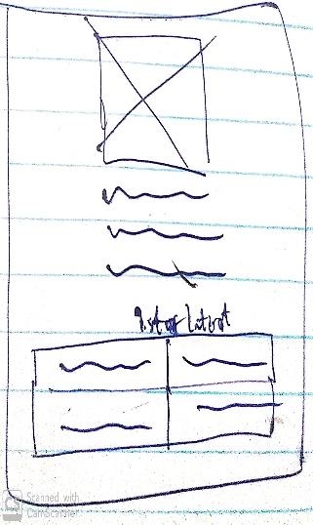
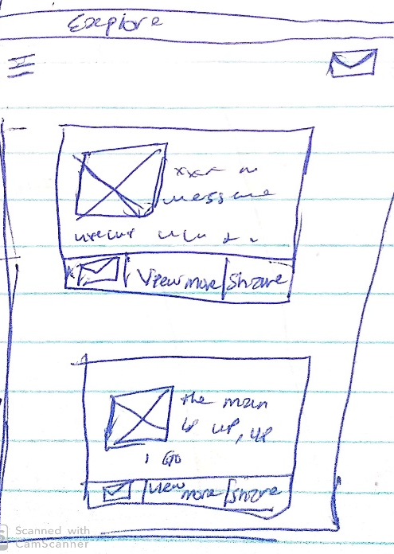 |  | 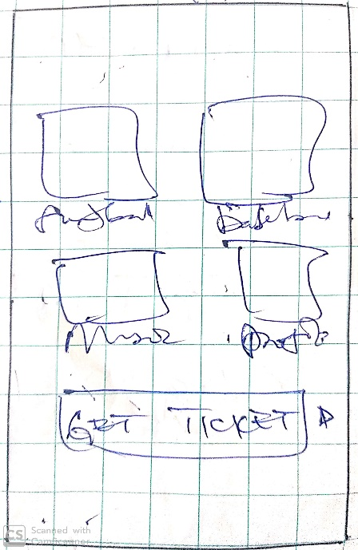
Figure XXIV All Voted Sketch

DETAILED MOCK-UP
Keys: Shows click to navigate
Shows Norman's principle
Application Screen | Norman's Principle | Explanation
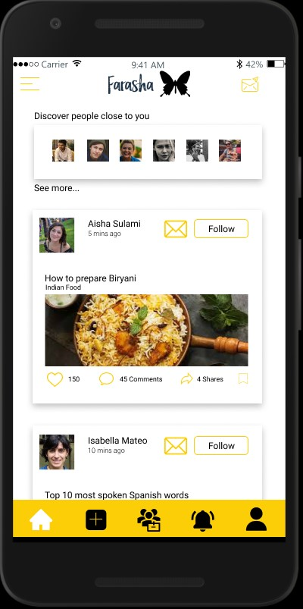  Figure XXV High Fidelity Explore page | According to Norman's principle, there is consistency in the colour as it remains white and yellow. Affordance also applies in the mail icon and the navigation bar at the bottom of the screen. | The explore page; also, the home page to the application shows the user the discovery features of the application, such as people's culture and others. The user can also navigate to the forum, find friends, direct message and other from this screen.
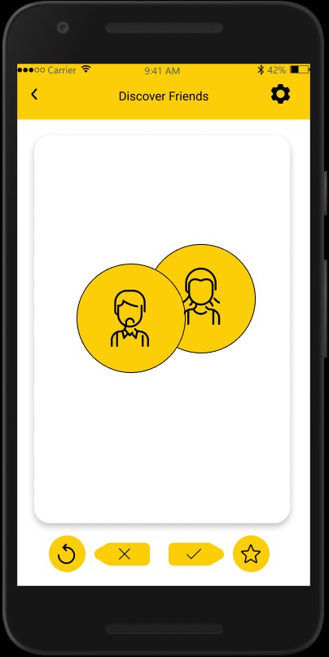  Figure XXVI High Fidelity Find Friend Loader page | The page shows the visibility principle as it keeps the user aware of the loading page to tell the user that his/her request is in process. | After the user clicks on the find friend feature of the explore page, the loading page appears to tell the user that his/her request is in process.
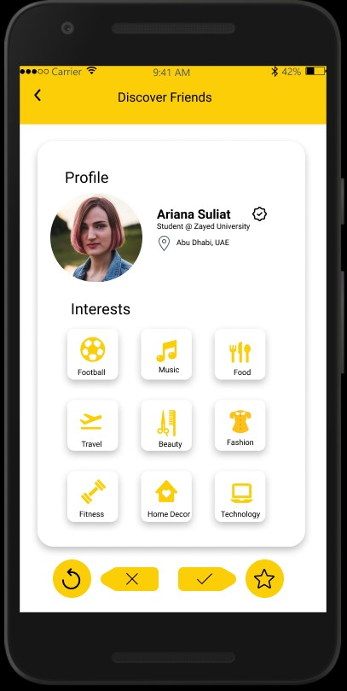  Figure XXVII High Fidelity Find Friend page | The accept and decline button follows Norman's mapping principle. | After the request has been processed the profile that best matches the user's interest appear. The user can then decide to pass on the found user or send a friend request through either the check or x button. After the user is done with this page, clicking on the top left-hand side of the screen where the arrow key is will take the user back to the home/explore page.
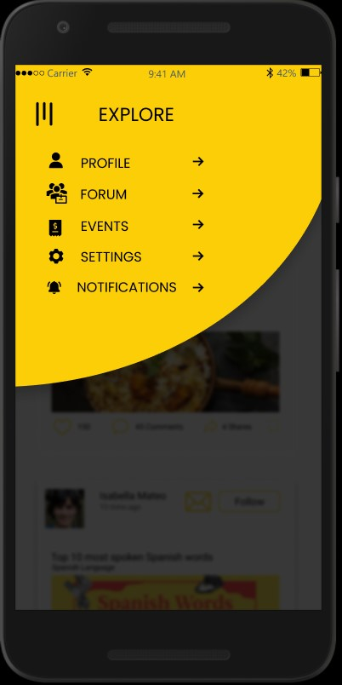  Figure XXVIII High Fidelity explore nav-bar |  | From the Explore page, the drop-menu navigation shows the forum page which can be clicked upon which will directly lead to the forum page.
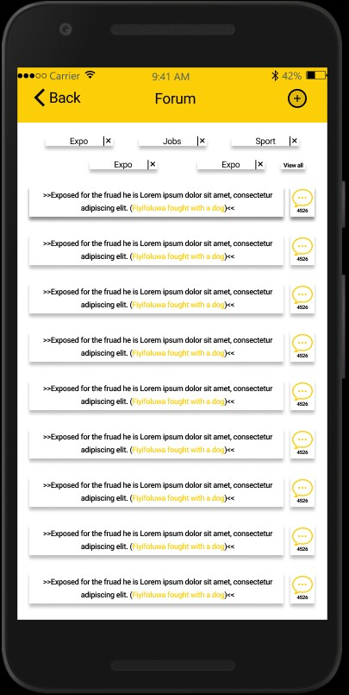  Figure XXIX High Fidelity Forum page |  | The forum page is where the user can get all the filtered news. By clicking the add button, the user can add and edit the category of news they receive. From this page, they can comment on any new of their choice
Figure XXX DETAILED MOCK-UP
LINK TO THE FULL MOCK-UP
https://www.figma.com/proto/DxTlnSA4fAzus5tus6uQiA/Farasha?node-id=514%3A1678&viewport=742%2C1471%2C0.1664174199104309&scaling=scale-down

DISCUSSION
The team had a great time creating the prototype Farasha since the application is based on social media which can be related by everyone on the team. The freedom to express their creativity in sketch and wireframing design has also brought the team a unique dynamic. The team also received much feedback during the phase. Since the team was familiar with Adobe XD the team first had some difficulties using the new prototyping tool "Figma". Lucky two members of the team were familiar with Figma, which provides the team with the room to learn and adapt.
The team did, however, face some difficulty along the way. The team had some problems delivering the mid-fidelity prototype on time for validation. Also, the sketches voted for were to advance. Hence, the iteration became a matter of concern as the result of the sketches were similar to the wireframing. There were also the implementing opportunities that were algorithm based on design such as the shared object.
In order to improve the Method used, user feedback will be needed. One of the team's primary focus for the third phase will be the user testing, which will involve the help of interview, survey and usability testing. As this is are the methods that will both guarantee a broad audience and detailed feedback from the user testing.

REFERENCE
Al-Refai, M., Zughoul, B., Al-Raba'nah, Y., Alauthman, M. and Muraish, A., 2017. Software Development by Merging Prototyping and Agile Approaches. International Journal of Advanced Research in Computer Science and Software Engineering, [online] 7(9), p.47. Available at: <https://www.researchgate.net/publication/319288275_Merging_Prototyping_with_Agile_Software_Development_Methodology> [Accessed 6 June 2020].
Chaz212, 2019. Storyboard Report. [online] Slideshare.net. Available at: <https://www.slideshare.net/Chaz212/storyboard-report> [Accessed 5 June 2020].
Clever Prototypes, L., n.d. What Is Cause and Effect in Stories? | Cause and Effect Diagram. [online] Storyboard That. Available at: <https://www.storyboardthat.com/articles/e/cause-and-effect#:~:text=Cause%20and%20Effect%20Examples&text=A%20very%20important%20part%20of,of%20events%20in%20the%20plot.&text=Creating%20a%20storyboard%20that%20depict,of%20cause%20and%20effect%20relationships.> [Accessed 5 June 2020].
Designsprintkit.withgoogle.com. n.d. Share and Engage with The Design Sprint Community. [online] Available at: <https://designsprintkit.withgoogle.com/methodology/phase3-sketch/crazy-8s> [Accessed 9 June 2020].
Illuscientia.com. n.d. Storyboard for Research Design | Illuscientia: Scientific Illustration & Animation - Graphisme & Illustration Scientifique. [online] Available at: <http://www.illuscientia.com/resources/storyboard-for-research-design/> [Accessed 5 June 2020].
Johnson, J. and Henderson, A., 2012. Conceptual Models Core to Good Design. 12th ed. Pennsylvania: Morgan and Claypool, pp.71- 79.
Johnson, J. and Henderson, A., 2013. Conceptual Models in A Nutshell - Boxes and Arrows. [online] Boxes and Arrows. Available at: <https://boxesandarrows.com/conceptual-models-in-a-nutshell/#:~:text=Object%2FOperation%20Analysis,perform%20on%20each%20object%2Dtype.> [Accessed 8 June 2020].
Medium. 2020. Validating Your Product Design Ideas with Low-Fidelity Wireframes. [online] Available at: <https://medium.com/@robertsmith_co/validating-your-product-design-ideas-with-low-fidelity-wireframes-fba03b84af23> [Accessed 9 June 2020].
Official GMI Blog. 2020. UAE Internet Statistics 2020 (Infographics). [online] Available at: <https://www.globalmediainsight.com/blog/uae-internet-and-social-media-usage-statistics/#:~:text=The%20frequency%20of%20internet%20usage,it%20once%20in%20a%20month.> [Accessed 6 June 2020].
Official GMI Blog. 2020. UNITED ARAB EMIRATES POPULATION STATISTICS (2020). [online] Available at: <https://www.globalmediainsight.com/blog/uae-population-statistics/> [Accessed 6 June 2020].
Pixel Fridge. 2020. How Detailed Should Wireframes Be? A Guide to Wireframe Fidelity | Pixel Fridge. [online] Available at: <https://pixelfridge.digital/2020/03/05/how-detailed-should-wireframes-be-a-guide-to-wireframe-fidelity/> [Accessed 9 June 2020].
Technology.tki.org.nz. 2012. Human Factors in Design / Design in Technology / Indicators: Learning Objectives / Technology Indicators / Technology in The NZC / Welcome to Technology Online - Technology Online. [online] Available at: <http://technology.tki.org.nz/Technology-in-the-NZC/Technology-indicators/Indicators-Learning-Objectives/Design-in-technology/Human-Factors-in-Design> [Accessed 5 June 2020].
The Interaction Design Foundation. n.d. What Is Agile Development? [online] Available at <https://www.interaction-design.org/literature/topics/agile-development> [Accessed 7 June 2020].
The Media Lab. 2019. UAE Digital Media Statistics 2019 (Infographics) - The Media Lab. [online] Available at: <https://www.themedialab.me/uae-digital-media-statistics-2019/> [Accessed 6 June 2020].
Thomson, p. and V., 2013. Story-Boarding the Thesis Structure. [online] patter. Available at: <https://patthomson.net/2013/03/28/story-boarding-the-thesis-structure/> [Accessed 5 June 2020].
Worldpopulationreview.com. 2020. [online] Available at: <https://worldpopulationreview.com/world-cities/dubai-population/> [Accessed 6 June 2020].

APPENDIX

Primary user Persona
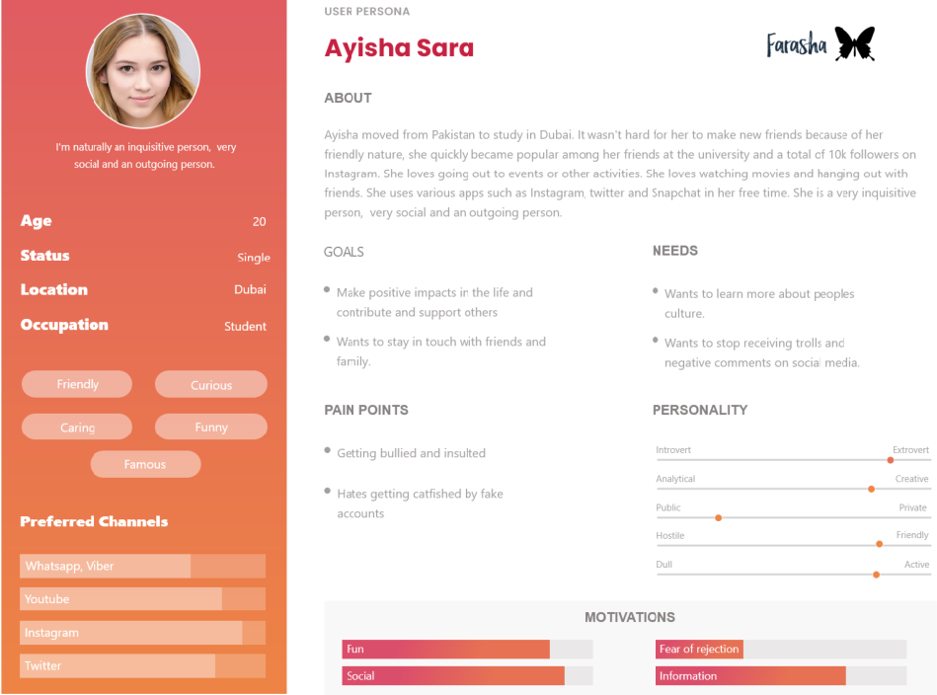

Primary user Journey map
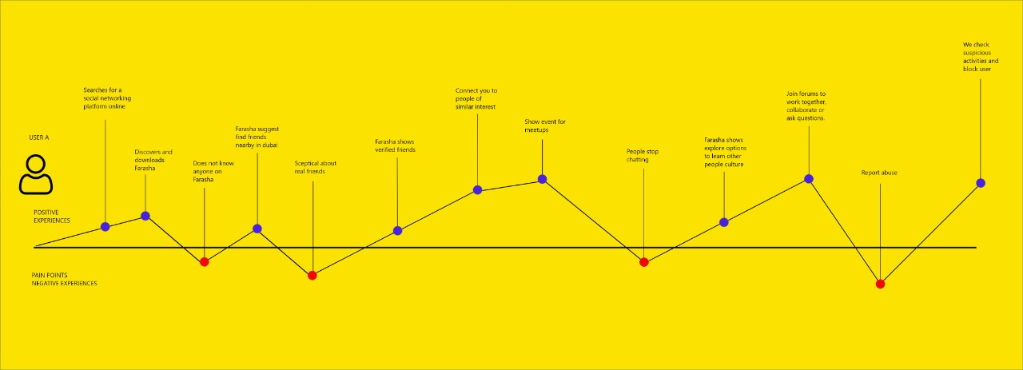

Primary user stories
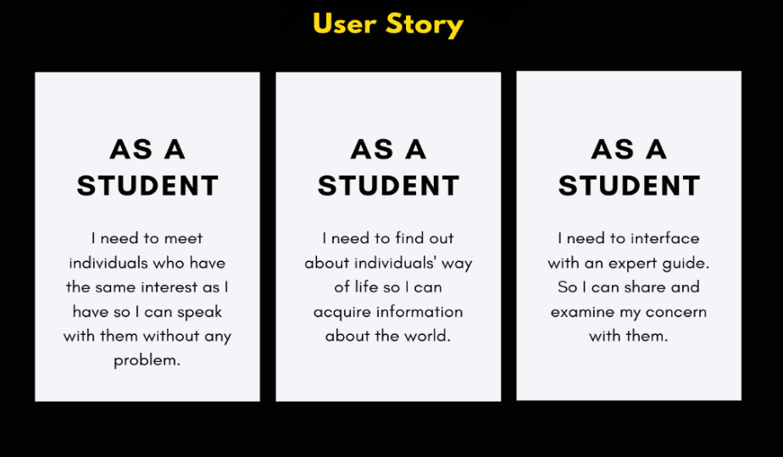

Primary user Scenarios
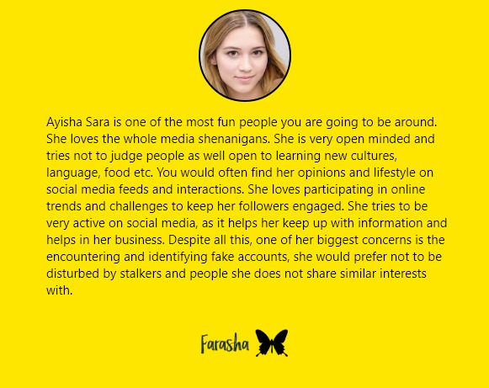

Sketches
Page Name | Crazy 8 Sketches
Event | 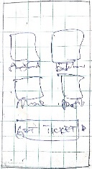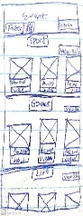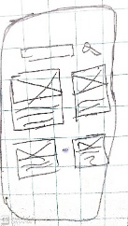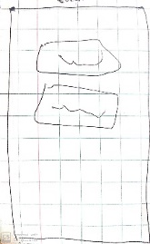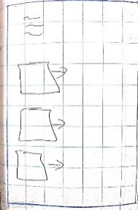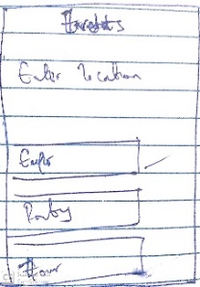
Explore | 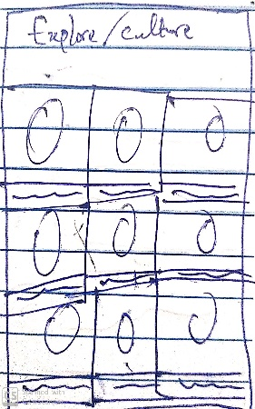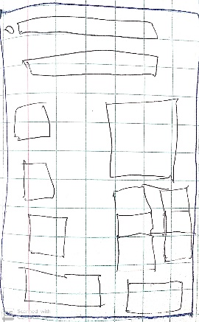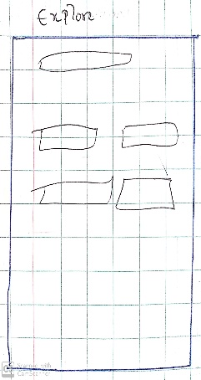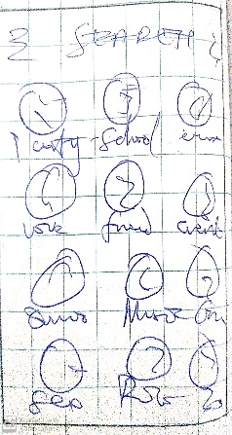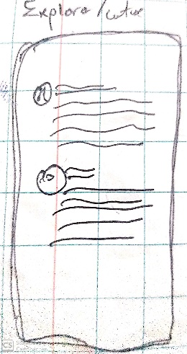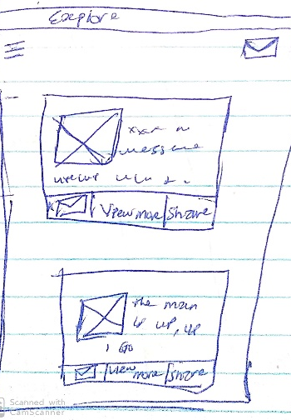
Discover Friends
Forum | 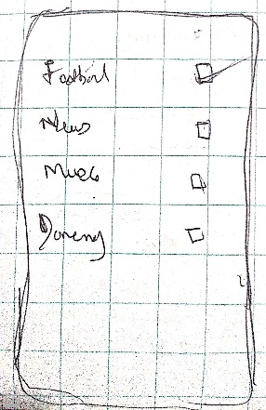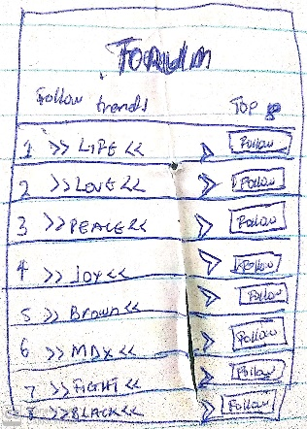
Log-in | 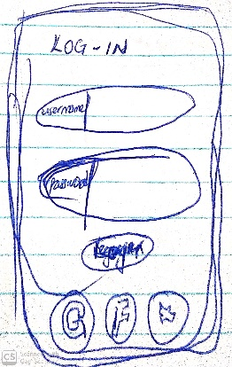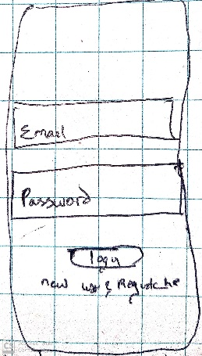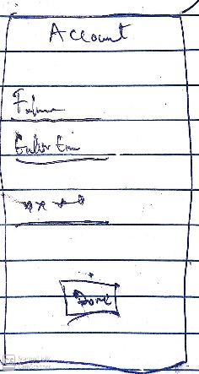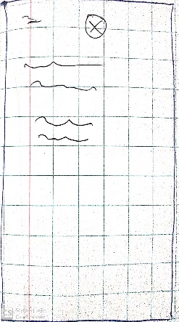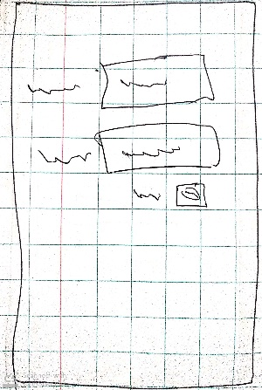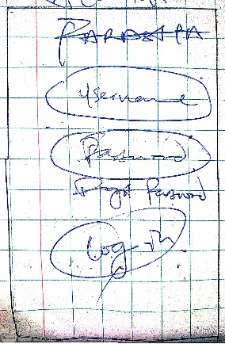
Message | 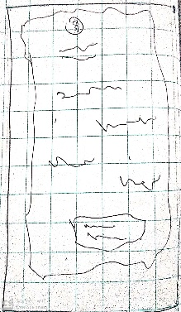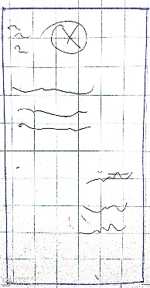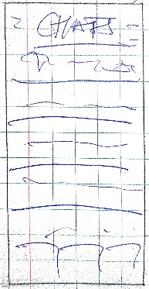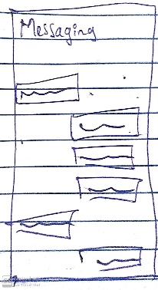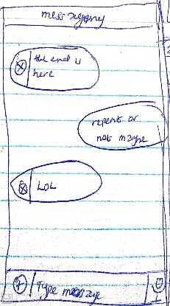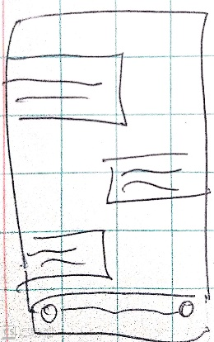
Notification | 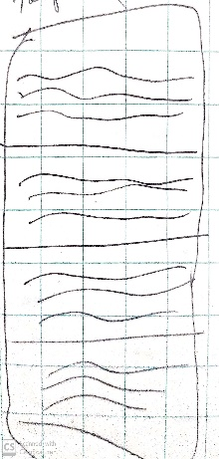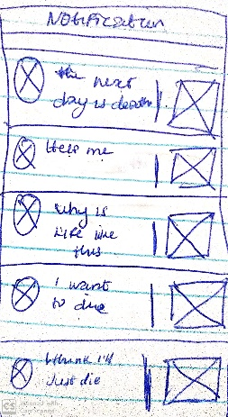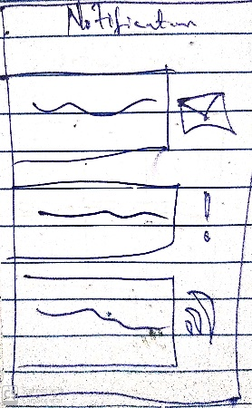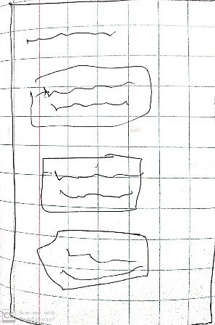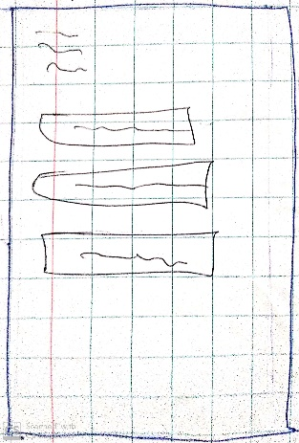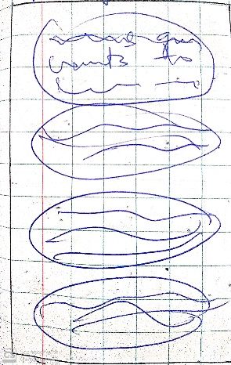
Find a friend | 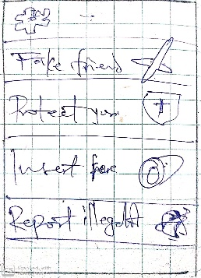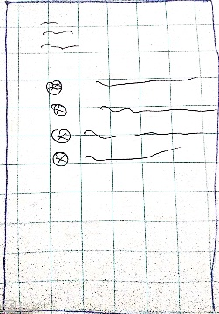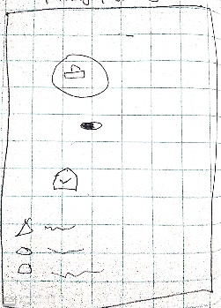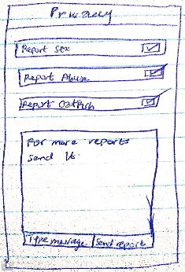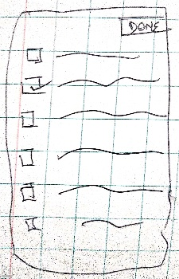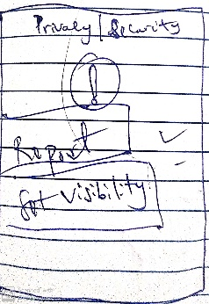
Profile Setup | 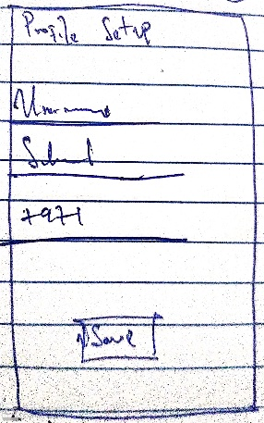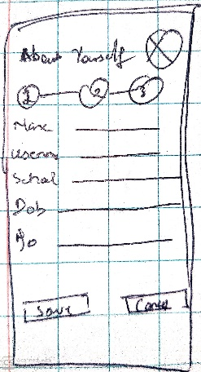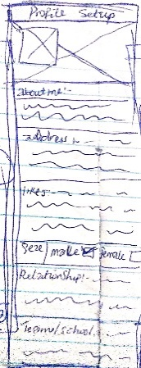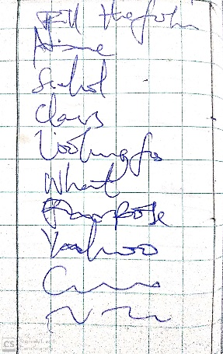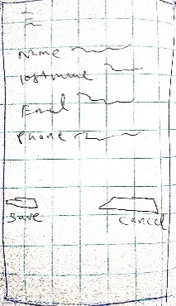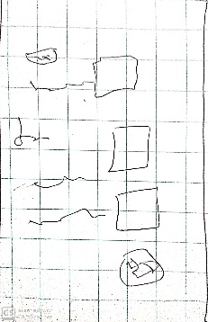
Register | 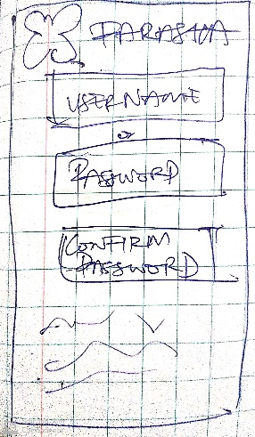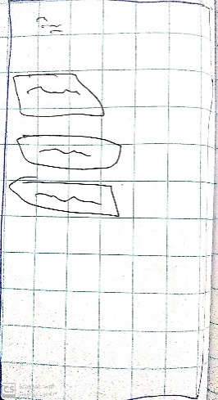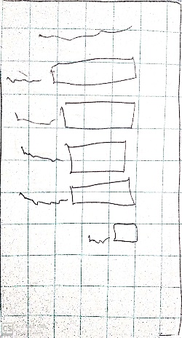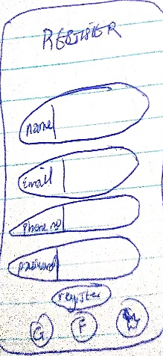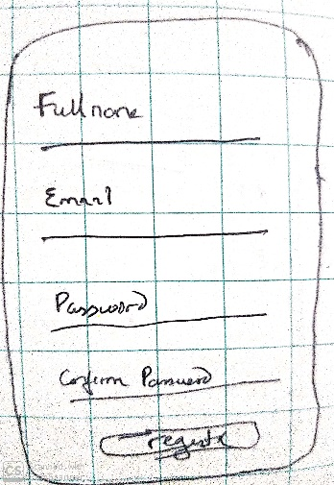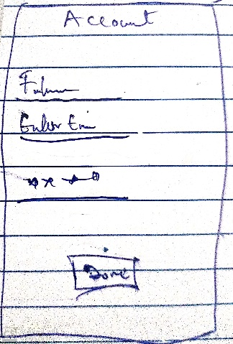

Mid Fidelity Wireframe
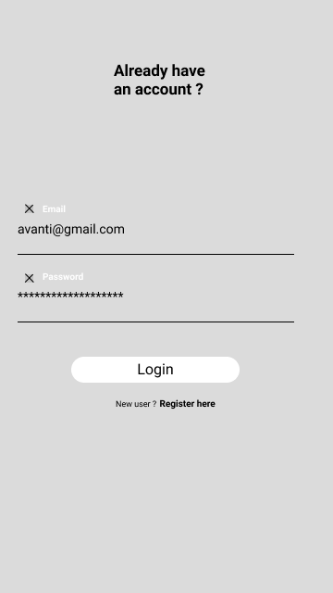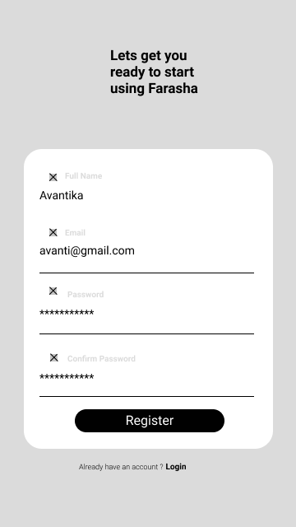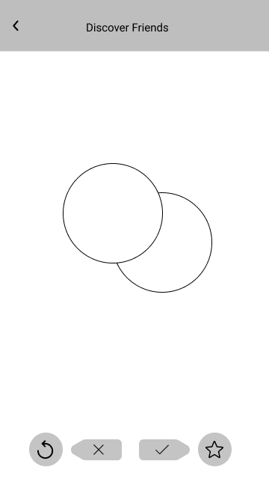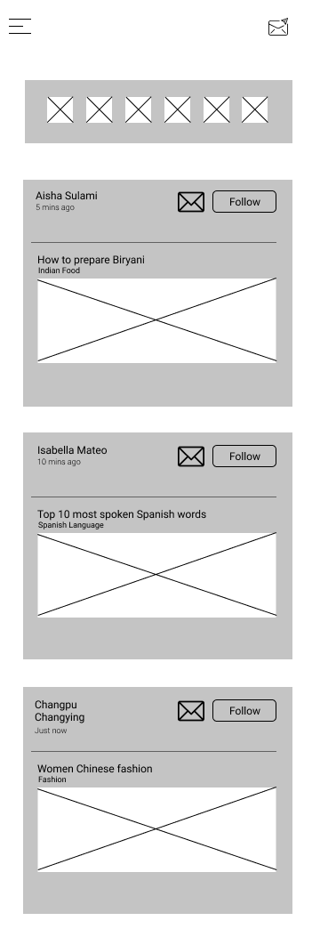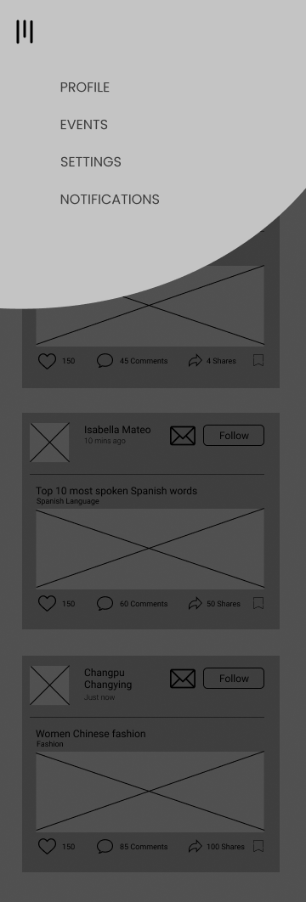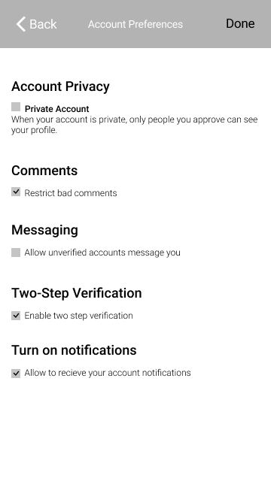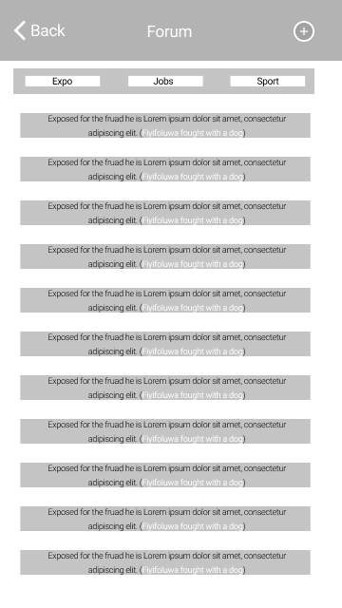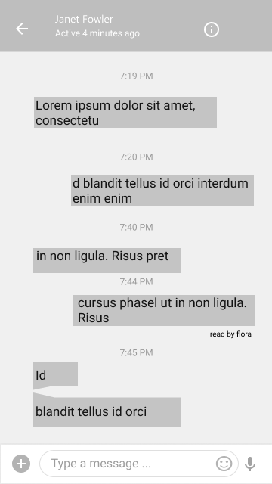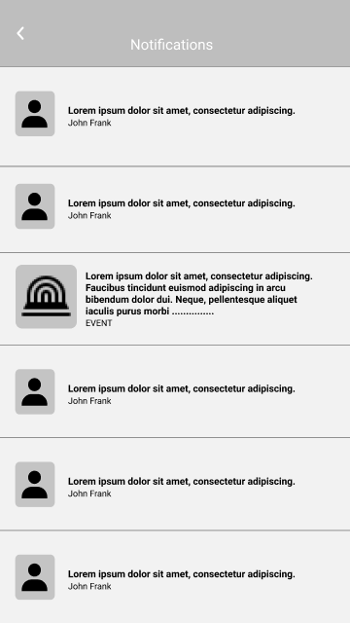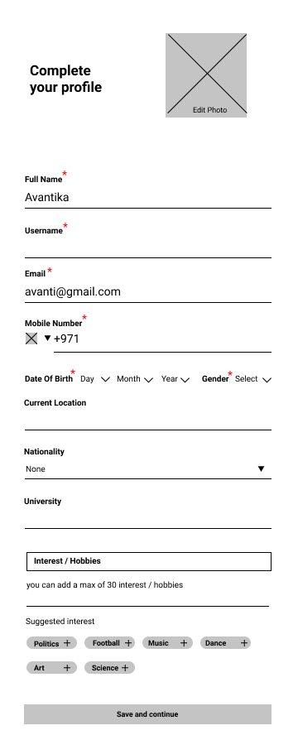

High Fidelity Wireframe
